ACADEMIC Formal Lab Report: Effects of Agriculture on Water Quality

Problem:
How does the choice of agricultural techniques affect the ability of water bodies to support plant and animal life? (Copy as written here)

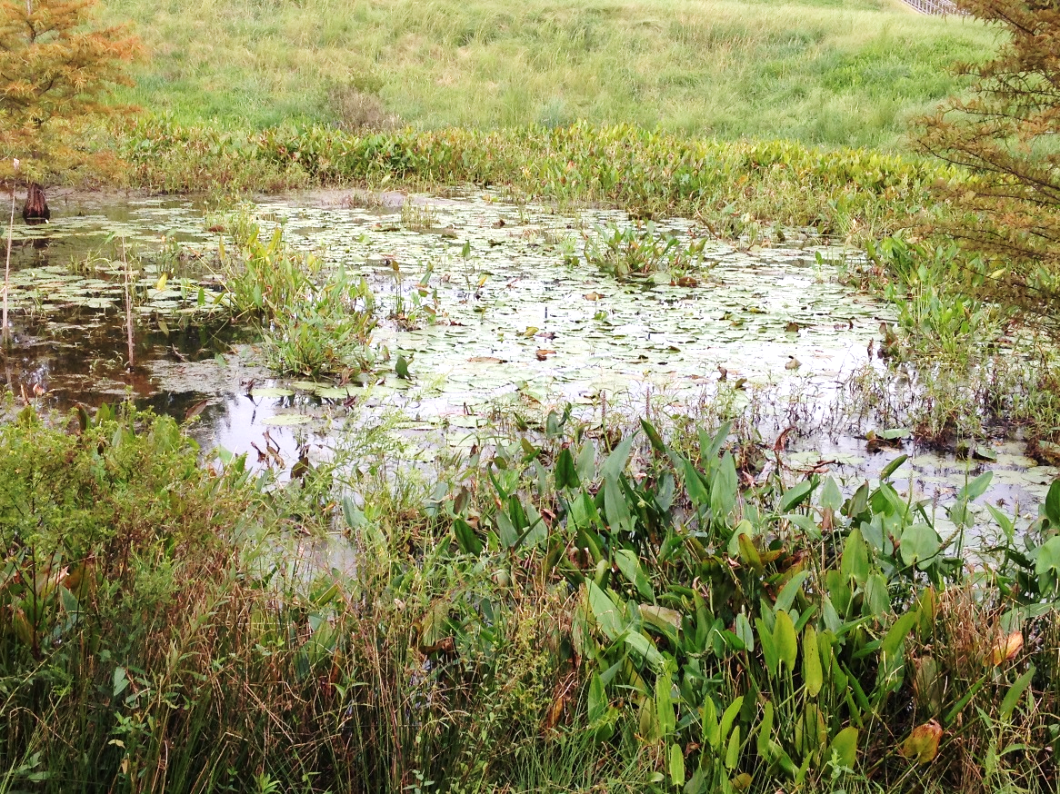
Background:
Site 1: PCHS Retention Pond Next to Mod 5

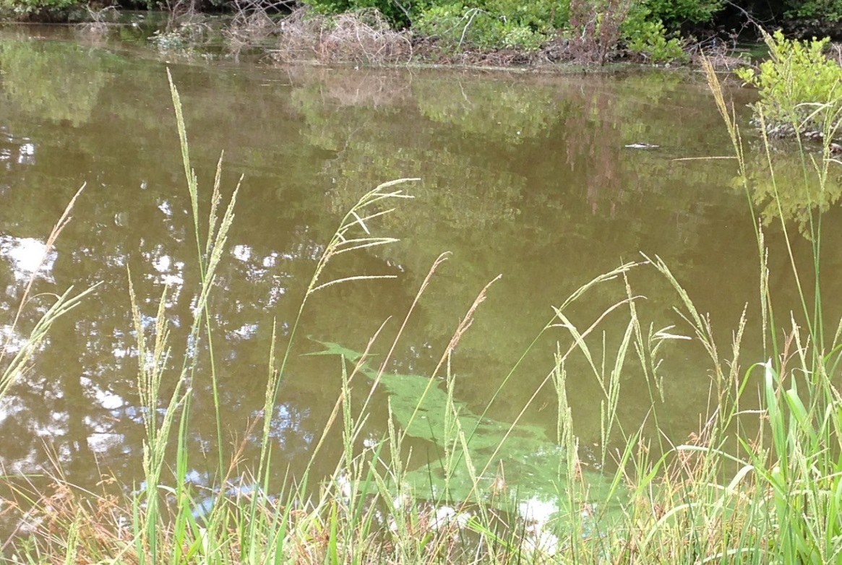
Site 2: Retention Pond from the Stockton Neighborhood in Angier, NC
Background paragraphs (5 sentences each—1 introductory, 3 body, and 1 conclusion)
Paragraph 1—Unit 3—Types of Farming (compare traditional versus no-till)
- Intro sentence
- Body sentence 1: what is traditional farming (including how it effects erosion)
- Body sentence 2: what is no-till farming (including how it effects erosion)
- Body sentence 3: compare the amounts of erosion caused by each type of farming
- Conclusion sentence: which type of farming is best for minimizing erosion
Paragraph 2—Unit 4—Erosion Tied to Turbidity & Eutrophication of Local Water Ways
- Intro sentence
- Body sentence 1: how does the rate of erosion affect the turbidity of water bodies nearby
- Body sentence 2: other than sediment, what else will erode from agricultural fields
- Body sentence 3: explain how the runoff from agricultural fields leads to eutrophication
- Conclusion sentence: which type of farming method is best minimizing turbidity and eutrophication
Paragraph 3—Unit 5—Dead Zones in Gulf of Mexico
- Intro sentence
- Body sentence 1: what is a dead zone
- Body sentence 2: what causes a dead zone to form
- Body sentence 3: trace the path of the chemicals responsible for the Gulf of Mexico dead zone from agricultural fields to the Gulf
- Conclusion sentence: which farming method is best for minimizing the formation of dead zones
Hypothesis:
Complete the following:
If the agricultural techniques are _______ sustainable near the PCHS pond, then the PCHS pond will have a _______ level of dissolved oxygen and ________ levels of nitrates, phosphates, and turbidity than the Stockton pond.

Materials:
- LaMotte: Water Monitoring Kit (Copy as written here)
- Freshwater sample from retention pond (Copy as written here)

Procedure:
Physical, chemical and biological tests were completed using instructions included in the LaMotte: Water Monitoring Kit. Tests performed include: temperature, turbidity, dissolved oxygen (DO), percent saturation of dissolved oxygen, nitrate, phosphate, pH, coliform bacteria and looking for other life forms. (Copy as written here)

Data:
Site 1: PCHS Retention Pond Next to Mod 5
Physical Tests | Result (Include Units) | Ranking (Number AND Word)
Temperature
Turbidity

Chemical Tests | Result | Ranking
Dissolved Oxygen (DO)
Percent Saturation of Dissolved Oxygen
Nitrate
pH
Phosphate

Biological Tests | Result | Ranking
Coliform Bacteria
Other Life

Site 2: Retention Pond from the Stockton Neighborhood in Angier, NC (Copy as written here)
Physical Tests | Result (Include Units) | Ranking (Number AND Word)
Temperature | 18°C
Turbidity | 70 JTU | 2 (fair)

Chemical Tests | Result | Ranking
Dissolved Oxygen (DO) | 0 ppm
Percent Saturation of Dissolved Oxygen | 0% | 1 (poor)
Nitrate | 20 ppm | 1 (poor)
pH | 6 | 3 (good)
Phosphate | 4 ppm | 2 (fair)

Biological Tests | Result | Ranking
Coliform Bacteria | Positive | 1 (poor)
Other Life | Green algae

Analysis:
Paragraph: Natural Water Quality of Ponds
- Claim (1 sentence): Identify which site/pond has the worst natural water quality (i.e. lower ability to support plant and animal life).
- Evidence and Reasoning (2-3 sentences for each test performed):
  - Turbidity
    - Compare the quantitative data for the two ponds.
    - Compare the qualitative rankings for the two ponds.
    - Connect the data and rankings to the claim written above.
  - Percent Saturation of Dissolved Oxygen
    - Compare the quantitative data for the two ponds.
    - Compare the qualitative rankings for the two ponds.
    - Connect the data and rankings to the claim written above.
  - Nitrates
    - Compare the quantitative data for the two ponds.
    - Compare the qualitative rankings for the two ponds.
    - Connect the data and rankings to the claim written above.
  - Phosphates
    - Compare the quantitative data for the two ponds.
    - Compare the qualitative rankings for the two ponds.
    - Connect the data and rankings to the claim written above.
- Summary (2-3 sentences): Explain how the overall claim was decided even though the data points do not all have the same ranking.

Conclusion:
- Paragraph: Pond Most Affected by Non-Sustainable Agricultural Practices
  - Claim (1 sentence each):
    - Identify which pond/site is most affected by non-sustainable agricultural practices (has the worst natural water quality).
    - Evaluate your original hypothesis—does the data support or reject it?
  - Evidence and reasoning (3-4 sentences):
    - Turbidity
      - Review the qualitative rankings for each site’s pond.
      - Explain how non-sustainable agricultural techniques affect turbidity levels.
      - Explain how turbidity lowers natural water quality.
    - Percent Saturation of Dissolved Oxygen
      - Review the qualitative rankings for each site’s pond.
      - Explain how non-sustainable agricultural techniques affect percent saturation of oxygen.
      - Explain how percent saturation of dissolved oxygen lowers natural water quality.
    - Nitrates
      - Review the qualitative rankings for each site’s pond.
      - Explain how non-sustainable agricultural techniques affect nitrate levels.
      - Explain how nitrates lower natural water quality.
    - Phosphates
      - Review the qualitative rankings for each site’s pond.
      - Explain how non-sustainable agricultural techniques affect phosphate levels.
      - Explain how phosphates lower natural water quality.
  - Summary (2-3 sentences):
    - Summarize the abilities of the ponds to support plant and animal life by referencing the qualitative rankings.
    - Summarize how the agricultural techniques used in an area affects the natural water quality of nearby water bodies by referencing abilities to support plant and animal life.
- Paragraph: Source of Error—these are NOT mistakes that could have been corrected (measuring incorrectly, not following directions, etc.). These are limitations to your data based on factors outside of your control. Consider how the tests are designed and performed, the way the results were determined, how and where the water was collected, etc.
  - Name 1 source of error.
  - Explain how (specifically) it most likely affected the data.

