key

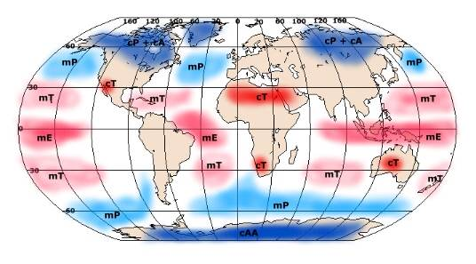

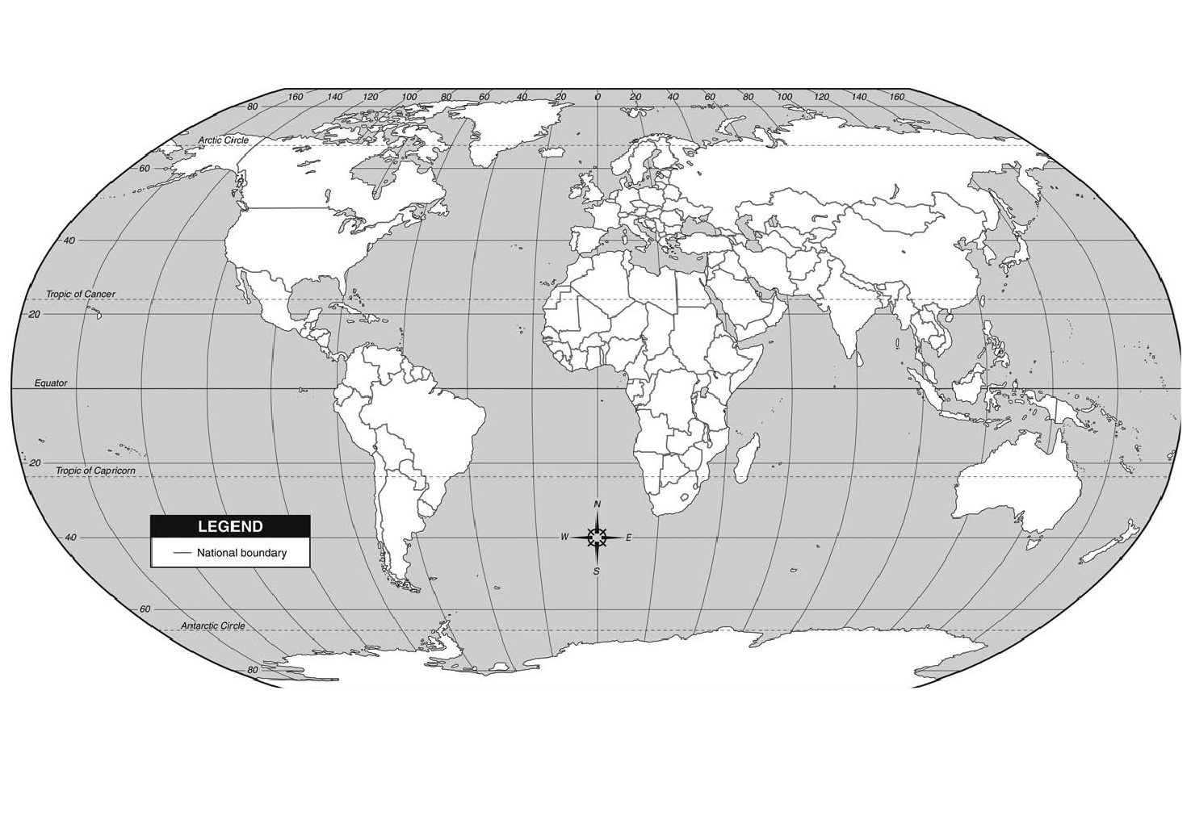Global Air Mass Originations Map

10

11

9

5

8

18

16

7

20

22

21

19

17

15

2

1

14

4

24

12

3

6

13

23