Biomes Crossword Puzzle

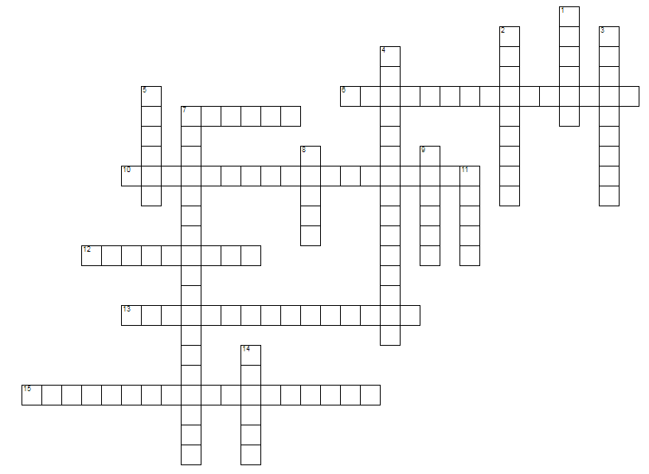

ACROSS
6 Few large mammals but many small along with reptiles, amphibians, birds, and insects
7 Soil below surface is frozen year-round
10 Many types and high amounts of mammals, insects, reptiles, birds, and monkeys
12 One of the best soils for growing plants
13 Rich topsoil but usually only a thin layer
15 Soil lacks nutrients due to rapid absorption by many plants

DOWN
1 Very few plants but all have adaptations for storing water
2 Cool winters but hot summers with low to moderate precipitation
3 Dominated by grasses rather than trees
4 Mild summers but cold winters with moderate to high precipitation
5 Very low precipitation with extreme seasons
7 Greatest density and variety of both plants and animals
8 Has acidic soil
9 Soil rich in minerals but poor in organic matter
11 Mostly evergreen plants that do not fall off yearly
14 Few animals but must either migrate or have adaptations for extreme cold

