Lab: Black-Footed Ferrets Name ______________________________

Background:
The Black-footed ferret is a species that was very recently threatened with complete extinction. Its survival has been part of a concentrated conservation effort. In trying to save the population, researchers have learned a great deal about the species’ unique niche in its ecosystem. Use the food web and additional information below to analyze the chances of survival for a hypothetical black-footed ferret population.

Canine distemper can be deadly to me!
Coyote
Owl
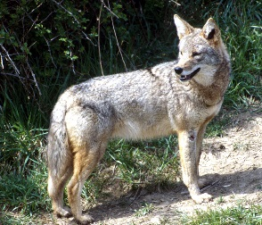
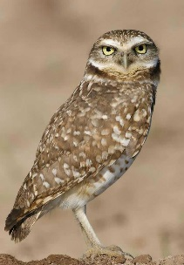
Badger
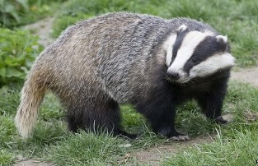

I steal burrows for shelter!
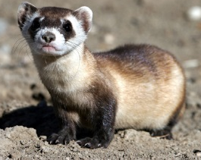

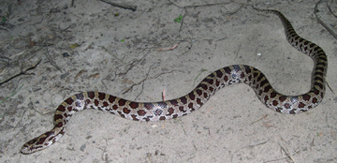
Snake
Black-footed Ferret

I dig burrows for shelter!
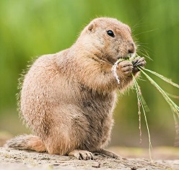
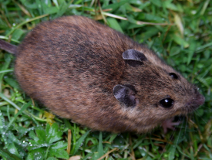

Mouse
Prairie Dog
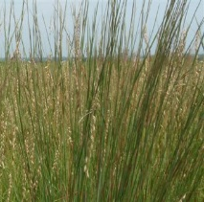

Grass

Objective: Using the color code key below (paper color = gene characteristic), evaluate the generic characteristics your hypothetical black-footed ferret population received through the genetic bottleneck event. Then answer the questions related to genetic diversity and characteristics.

Procedure:
- Sort, count, and record your population’s genes (color squares).

Black: precise vision
Orange: accurate smell
Red: large litter size
Pink: strong claws/legs
Brown: immunity to canine distemper
Purple: accurate hearing
Green: agility
Yellow: camouflage
Dark blue: strong jaw and teeth
Light blue: immunity to Sylvatic plague

Gene Frequency:
Gene | Frequency (# of Squares/Copies)
Precise Vision
Accurate Smell
Large Litter Size
Strong Claws/Legs
Immunity to Canine Distemper
Accurate Hearing
Agility
Camouflage
Strong Jaw and Teeth
Immunity to Sylvatic Plague

- Calculate the percent genetic diversity of your hypothetical black-footed ferret population. 10 different genes represent 100% genetic diversity in the original black-footed ferret population. In order for a gene to be counted as present in the population, there must be at least 3 copies of the gene.
- How many genes do you have? _______ out of 10
- Calculate the percentage of genes (from those possible) within your population:

(_____/10) * 100 = ______%
- Create a bar graph showing the population’s gene frequency.
  - Title (compares independent and dependent variables)
  - Frequency of Gene: Y-axis label and scale
  - Gene/Characteristic: X-axis label and scale
  - Color-coded to match genes received

- Impact of genes on ferret population:
In order for your population to pass along genes from one generation to the next, there must be at least 3 copies of the same gene in the population. Any less than that means only a few individuals will be impacted instead the population as a whole.
  - On the graph, indicate with a horizontal line the threshold for genes to be passed on to the next generation.
  - In what ways will your population of ferrets be strong?

  - In what ways will your population of ferrets by weak?

Analysis:
Using the situations below that have taken place where your hypothetical back-footed population lives, what is the impact to your population? Use the genetic information to decide whether your ferret population will survive and increase or if they will decrease and die off. Discuss what will happen to your population based on their genes and the event.
Scenario | Impact on Population  (Detailed discussion of how the event and your population’s genes result in said impact)
- Prairie dog population evolves tougher skin and thicker fur. | Impact:  (increase/decrease)  Discussion:
- Fewer opportunities for females to become pregnant. | Impact:  (increase/decrease)  Discussion:
- Coyotes with deadly canine distemper disease roam through the area. | Impact:  (increase/decrease)  Discussion:
- A new group of captive-born black-footed ferrets is released in the same area (no additional resources provided). | Impact:  (increase/decrease)  Discussion:
- A coyote (with a strong odor) prowls at night. | Impact:  (increase/decrease)  Discussion:
- A great horned owl relies on its keen eyesight to spot potential prey (ferrets) in the dark. | Impact:  (increase/decrease)  Discussion:
- A predatory badger quietly sneaks around the ferret town. | Impact:  (increase/decrease)  Discussion:
- Drought causes the prairie soil to compact and harden, making it harder to burrow into the soil. | Impact:  (increase/decrease)  Discussion:

Conclusion:
- What percentage of scenarios did the population survive?

- If the population had greater diversity (all 10 genes or even more), would its ability to survive be higher or lower? Explain why!

