Climatogram Project: Temperature, Rainfall, and Biome Distribution

Welcome to your climatogram project. In this project you will investigate the relationship between the amount of rainfall and the variance of temperature and the effect on the distribution of biomes globally.

Purpose:
This project provides practice in associating climate (as expressed in monthly averages of precipitation and temperature) with biomes. You will also make predictions about the distribution of a biome via altitude and latitude.
Large ecosystems or biomes can be described in terms of their climate, or long-term weather patterns. The climate of a biome is the result of the interaction of several abiotic factors. These factors include temperature, precipitation, and radiant energy from the sun, evaporation, wind and humidity. These abiotic factors serve to limit the diversity of plants and animals found within an ecosystem. The two most important of these limiting abiotic factors are temperature and precipitation. A climatogram is a graph with a double-Y axis that plots the average monthly temperature & precipitation in a biome.
Climatograms of a large ecosystem (or biome) show variation in only two factors- temperature and precipitation. Although there are other factors that affect the climate, a climatogram does give a rough idea of the climate in a particular biome.

Score Sheet:
Part I:
Part A
- Calculations _____/8

- 4 Climatograms _____/12 (Labels, Format, Accuracy)
Part B
- Questions _____/12
Part II:
- Calculations _____/2

- Climatogram _____/3 (Labels, Format, Accuracy)

- Questions _____/8
Part III:
Academic
- 4 Climatograms _____/24 (Labels, Form, Accuracy)

- 4 Analysis Statements _____/24
Honors
- 8 Climatograms _____/24 (Labels, Form, Accuracy)

- 8 Analysis Statements _____/24
Appearance:
Neatness of Climatograms _____/4

Legibility of Writing _____/3

Late Deduction (-10pts per day) ________

Total Project Score _____/100 (2 Lab Grades)
Part I: Known Biomes—Building a Library of Examples

Known Biomes Part A
- Graph the climate figures for precipitation and temperature for the four locales in Known Biomes Part 1 onto your blank climatogram sheets (found at the end of the data).
  - Be sure that you label each location and its biome name.
  - Also be extremely careful as to how you record the information. All temperature readings are measured on the right side of the climatogram! All precipitation measurements are on the left side of the climatogram!
  - Be sure to draw a line graph for temperature data and a bar graph for precipitation data.
- Calculate the average temperature. See me for help if necessary. Record the value below each data table and on the climatogram.
- Calculate the total precipitation for each data set. Record the value below each data table and on the climatogram.

Cuiaba, Brazil: Tropical Deciduous Forest
 | J | F | M | A | M | J | J | A | S | O | N | D
Precipitation (in cm): | 24.9 | 21.1 | 21.1 | 10.2 | 5.3 | 0.8 | 0.5 | 2.8 | 5.1 | 11.4 | 15 | 20.6
Temperature (in C°): | 27.2 | 27.2 | 27.2 | 26.6 | 25.6 | 23.9 | 24.4 | 25.6 | 27.8 | 27.8 | 27.8 | 27.2

Average Temperature in Celsius: __________ Total Rainfall in cm: __________

Santa Monica, California: Chaparral
 | J | F | M | A | M | J | J | A | S | O | N | D
Precipitation (in cm): | 8.9 | 7.6 | 7.4 | 1.3 | 1.3 | 0 | 0 | 0 | 0.3 | 1.5 | 3.5 | 5.8
Temperature (in C°): | 11.7 | 11.7 | 12.8 | 14.4 | 15.6 | 17.2 | 18.9 | 18.3 | 18.3 | 16.7 | 14.4 | 12.8

Average Temperature in Celsius: __________ Total Rainfall in cm: __________

Moshi,Tanganyika: Tropical Grassland
 | J | F | M | A | M | J | J | A | S | O | N | D
Precipitation (in cm): | 3.6 | 6.1 | 9.2 | 40.1 | 30.2 | 5.1 | 5.1 | 2.5 | 2 | 3 | 8.1 | 6.4
Temperature (in C°): | 23.3 | 23.2 | 22.2 | 21.1 | 19.8 | 18.4 | 17.9 | 18.4 | 19.8 | 21.4 | 22 | 22.4

Average Temperature in Celsius: __________ Total Rainfall in cm: __________

Aden, Aden: Tropical Desert
 | J | F | M | A | M | J | J | A | S | O | N | D
Precipitation (in cm): | 0.8 | 0.5 | 1.3 | 0.45 | 0.3 | 0.3 | 0 | 0.3 | 0.3 | 0.3 | 0.3 | 0.3
Temperature (in C°): | 24.6 | 25.1 | 26.4 | 28.5 | 30.6 | 31.9 | 31.1 | 30.3 | 31.1 | 28.8 | 26.5 | 25.1

Average Temperature in Celsius: __________ Total Rainfall in cm: __________

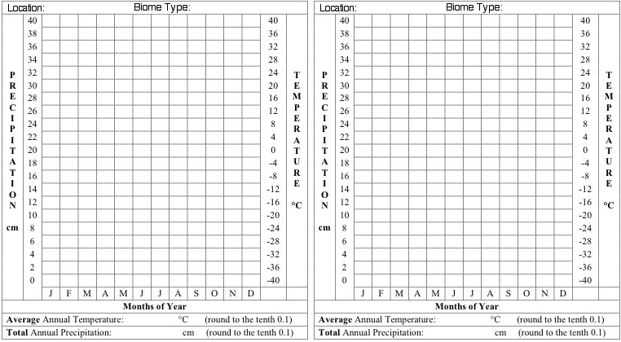

Known Biomes Part B
Combined with the six climatograms given as examples below, you now have ten climatograms representing ten different biome found worldwide.

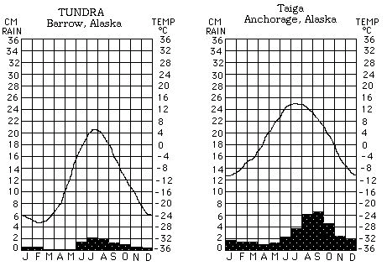
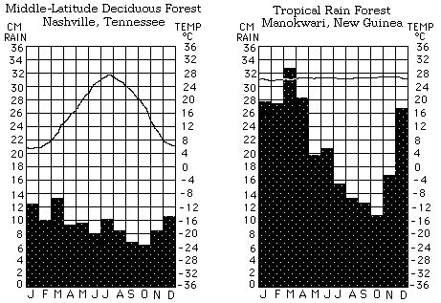

Examine the 10 climatograms for the known biomes (your 4 plus the 6 provided) and answer the questions below.

- How are the Tundra and Desert similar? Different?
  - Similar-

  - Different-

- How are the Tropical Rain and Tropical Deciduous Forests similar? Different?
  - Similar-

  - Different-

- Lawrence, Kansas and Nashville, Tennessee occupy similar latitudes. Why is one found in grassland and the other in a forest biome?

- Considering that the information in your climatograms is presented on a monthly basis. How would you determine which biomes are located in the southern hemisphere?

- Which biome has the:

  - Most rainfall-

  - Least rainfall-

  - The highest average temperature-

  - The lowest average temperature-

  - Most consistent year round temperature-

  - Most variable year round temperature-

Part II: San Francisco Case Study

Create the climatogram for San Francisco.
  - Be sure that you label each location and its biome name.
  - Also be extremely careful as to how you record the information. All temperature readings are measured on the right side of the climatogram! All precipitation measurements are on the left side of the climatogram!
  - Be sure to draw a line graph for temperature data and a bar graph for precipitation data.

 | J | F | M | A | M | J | J | A | S | O | N | D
Precipitation (in cm): | 4.5 | 2.8 | 2.6 | 1.5 | 0.3 | 0.1 | 0 | 0.1 | 0.2 | 1.1 | 2.5 | 3.5
Temperature (in C°): | 13.0 | 15.0 | 16.0 | 17.0 | 17.0 | 19.0 | 18.0 | 18.0 | 21.0 | 20.0 | 17.0 | 14.0

Average Temperature in Celsius: __________ Total Rainfall in cm: __________

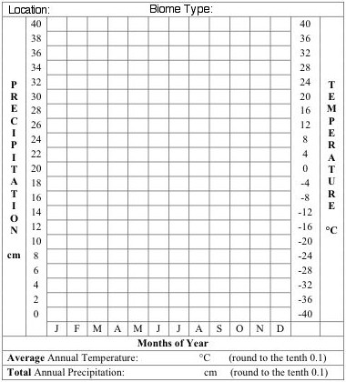

Compare the climatogram for San Francisco with the ten known Biomes from Part I and answer the following questions about San Francisco.

- Which of the known biome climatograms closely resembles San Francisco?

  - In what ways were they similar?

  - In what ways were they different?

  - Would you consider them to truly be the same biome? Explain why/why not.

  - During the thirty-year period used for the figures in the San Francisco climatogram there were four drought periods. How would this effect the appearance of the climatogram?

- In what biome is San Francisco actually found? Research this!

  - Does this match your analysis?

  - Explain why or why not.
Part III: Making Climatograms for Unknown Biomes
Academic Students: Complete climatograms and analysis statements for A-D only!
Honors Students: Complete climatograms and analysis statements for all (A-H)!

Creating climatograms for the unknown biomes/locations.
- Be sure that you label each location and its biome name.
- Also be extremely careful as to how you record the information. All temperature readings are measured on the right side of the climatogram! All precipitation measurements are on the left side of the climatogram!
- Be sure to draw a line graph for temperature data and a bar graph for precipitation data.

UNKNOWN A
 | J | F | M | A | M | J | J | A | S | O | N | D
Precipitation (in cm): | 8.1 | 7.6 | 8.9 | 8.4 | 9.2 | 9.9 | 11.2 | 10.2 | 7.9 | 7.9 | 6.4 | 7.9
Temperature (in C°): | 1.1 | 1.7 | 6.1 | 12.2 | 17.8 | 22.2 | 25 | 23.3 | 20 | 13.9 | 7.8 | 2.2

Average Temperature in Celsius: __________ Total Rainfall in cm: __________

UNKNOWN B
 | J | F | M | A | M | J | J | A | S | O | N | D
Precipitation (in cm): | 9.1 | 8.9 | 8.6 | 6.6 | 5.1 | 2 | 0.5 | 0.5 | 3.6 | 8.4 | 10.9 | 10.4
Temperature (in C°): | 10.6 | 11.1 | 12.2 | 14.4 | 15.6 | 19.4 | 21.1 | 21.7 | 20 | 16.7 | 13.9 | 11.1

Average Temperature in Celsius: __________ Total Rainfall in cm: __________

UNKNOWN C
 | J | F | M | A | M | J | J | A | S | O | N | D
Precipitation (in cm): | 25.8 | 24.9 | 31 | 16.5 | 25.4 | 18.8 | 16.8 | 11.7 | 22.1 | 18.3 | 21.3 | 29.2
Temperature (in C°): | 25.6 | 25.6 | 24.4 | 25 | 24.4 | 23.3 | 23.3 | 24.4 | 24.4 | 25 | 25.6 | 25.6

Average Temperature in Celsius: __________ Total Rainfall in cm: __________

UNKNOWN D
 | J | F | M | A | M | J | J | A | S | O | N | D
Precipitation (in cm): | 1 | 1.3 | 1 | 0.3 | 0 | 0 | 0.3 | 1.3 | 0.5 | 0.5 | 0.8 | 1
Temperature (in C°): | 12.8 | 15 | 18.3 | 21.1 | 25 | 29.4 | 32.8 | 32.2 | 28.9 | 22.2 | 16.1 | 13.3

Average Temperature in Celsius: __________ Total Rainfall in cm: __________

UNKNOWN E
 | J | F | M | A | M | J | J | A | S | O | N | D
Precipitation (in cm): | 2.3 | 1.8 | 2.8 | 2.8 | 3.2 | 5.8 | 5.3 | 3 | 3.6 | 2.8 | 4.1 | 3.3
Temperature (in C°): | -3.9 | -2.2 | 1.7 | 8.9 | 15 | 20 | 22.8 | 21.7 | 16.7 | 11.1 | 5 | -0.6

Average Temperature in Celsius: __________ Total Rainfall in cm: __________

UNKNOWN F
 | J | F | M | A | M | J | J | A | S | O | N | D
Precipitation (in cm): | 0 | 0 | 1.5 | 0.5 | 8.9 | 14.7 | 12.2 | 8.1 | 2 | 1 | 0.3 | 0.8
Temperature (in C°): | 19.4 | 18.9 | 18.3 | 16.1 | 15 | 13.3 | 12.8 | 13.3 | 14.4 | 15 | 16.7 | 17.8

Average Temperature in Celsius: __________ Total Rainfall in cm: __________

UNKNOWN G
 | J | F | M | A | M | J | J | A | S | O | N | D
Precipitation (in cm): | 1 | 1.3 | 1.8 | 1.5 | 1.5 | 1.3 | 2.3 | 2.8 | 2.8 | 2.8 | 2.8 | 1.3
Temperature (in C°): | -22.2 | -22.8 | -21.1 | -14.4 | -0.39 | 1.7 | 5 | 5 | 1.1 | -3.9 | -10 | -17.2

Average Temperature in Celsius: __________ Total Rainfall in cm: __________

UNKNOWN H
 | J | F | M | A | M | J | J | A | S | O | N | D
Precipitation (in cm): | 3.6 | 4.1 | 4.6 | 6.9 | 8.1 | 6.9 | 6.4 | 6.6 | 8.9 | 5.1 | 5.6 | 4.6
Temperature (in C°): | 11.7 | 12.8 | 17.2 | 20.6 | 23.9 | 27.2 | 28.3 | 28.3 | 26.1 | 21.1 | 16.1 | 12.2

Average Temperature in Celsius: __________ Total Rainfall in cm: __________

Analysis Statements:
- Compare the unknown climatograms you have created to the ten known Biomes from Part I and determine the biome for each of the unknown climatograms. Record this on each climatogram.
- Write a brief explanation (3 sentences) for each unknown describing which biome you matched it to and why.
  - Identify the unknown by the letter and the matched biome by the name.
  - Be sure to discuss temperature and precipitation patterns in your analysis.
  - These must be written neatly on a separate sheet of paper and attached to the back of this project packet.

EXTRA CLIMATOGRAMS—CUT AND PASTE OVER ERRORS

