Name____________________________________________ Date: ___________________ Period: _________
Climatograms
Since climate is such an important property of a biome, scientists have developed what they call climatograms (climatographs) as s simple way of describing climate. A climatogram summarizes, in a graph, the monthly variation in temperature and precipitation. Other factors can also affect climate, but with experience you can get enough information from a climatogram to make generalizations about the distribution and adaptations of many organisms in an area.
In this activity, you will construct multiples climatograms based on temperature and precipitation data. The climatograms can then be used to compare different climates from around the world.
PROCEDURE:
- Study the sample climatograms (tundra and boreal forest) on the next page. The months of the year are along the bottom. The bar graph indicates average monthly precipitation (in cm) and uses the scale along the left side. The line graph indicates average monthly temperature (in °C) and uses the scale along the right side.
- Draw a climatogram for each of the four sets of data in Table 1. These four climatograms, plus the two on the next page, represent the major terrestrial biomes around the world. (You are given space to construct 6 climatograms. You will have the 4 in this step plus the one from number 3 below. The 6th one is an extra in case you make a mistake).
- Construct a climatogram for the Durham-Chapel Hill area based on the data in Table II.
- Compare the climatogram from Chapel Hill to the Biomes A through D and the two samples. Which one does Chapel Hill most closely resemble? ____________________________________________
  - In what ways is the Chapel Hill climatogram different from the other Biomes?

  - Which Biome is located in the southern hemisphere? How are you able to tell?

  - Which Biome consistently has little precipitation throughout the year?

  - Which Biome received the largest amount of precipitation throughout the year?

  - Which Biome reached the highest temperature?

  - Which Biome experienced a temperature range of 1 to 25°C?
SAMPLE CLIMATOGRAMS:

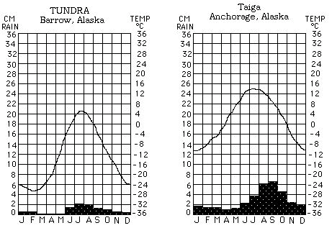

TABLE I – Biomes A-D

T = temperature in ºC P = precipitation in cm
 | J | F | M | A | M | J | J | A | S | O | N | D
Biome A – Iquitos, Peru
T | 25.5 | 25.6 | 24.4 | 25.0 | 24.4 | 23.3 | 23.3 | 24.4 | 24.4 | 25.0 | 25.6 | 25.6
P | 25.8 | 24.9 | 31.0 | 16.5 | 25.4 | 18.8 | 16.8 | 11.7 | 22.1 | 18.3 | 21.3 | 29.2
Biome B – Washington, DC
T | 1.1 | 1.7 | 6.1 | 12.2 | 17.8 | 22.2 | 25.0 | 23.3 | 20.0 | 13.9 | 7.8 | 2.2
P | 8.1 | 7.6 | 8.9 | 8.4 | 9.2 | 9.9 | 11.2 | 10.2 | 7.9 | 7.9 | 6.4 | 7.9
Biome C – Yuma, Arizona
T | 12.8 | 15.0 | 18.3 | 21.1 | 25.0 | 29.4 | 32.8 | 32.2 | 28.9 | 22.2 | 16.1 | 13.3
P | 1.0 | 1.3 | 1.0 | 0.3 | 0.0 | 0.0 | .03 | 1.3 | 0.5 | 0.5 | 0.8 | 1.0
Biome D – Bahia Blanca, Argentina
T | 23.3 | 22.2 | 19.4 | 15.6 | 11.7 | 8.3 | 8.3 | 9.4 | 12.2 | 15.1 | 18.9 | 21.7
P | 5.1 | 5.6 | 6.6 | 5.6 | 2.8 | 0.9 | 2.5 | 4.1 | 5.8 | 5.8 | 5.1 | 5.3

TABLE II – Durham/Chapel Hill

Biome Chapel Hill/Durham
 | J | F | M | A | M | J | J | A | S | O | N | D
T | 4 | 5 | 9 | 15 | 19 | 23 | 25 | 23 | 21 | 15 | 8 | 5
P | 9 | 10 | 11 | 9 | 10 | 10 | 11 | 12 | 9 | 8 | 8 | 9

- Biome A ____________________

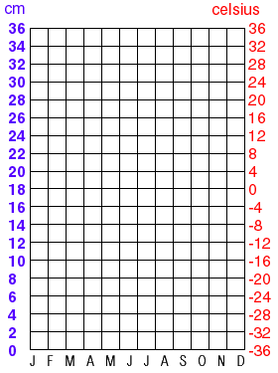

- Biome B_____________________
- Biome C ____________________

- Biome D ____________________
- Durham/Chapel Hill _______________

- EXTRA ____________________
Using Climatograms to Identify Bomes

Determine the biome represented by each of the climatograms below. Choose from Humid Mid-Latitude, Continental, Polar, Dry, or Humid Tropical. Then identify why that is the correct biome based on the temperature and precipitation patterns.

- Biome:________________________________
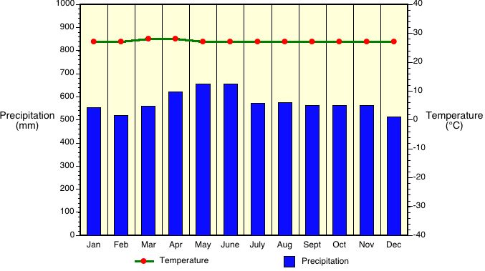
Temperature:__________________________
Precipitation:__________________________

- Biome:________________________________
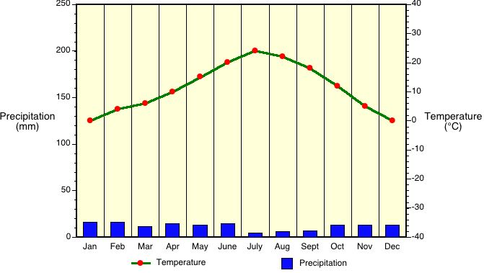
Temperature:__________________________
Precipitation:__________________________

- Biome:________________________________
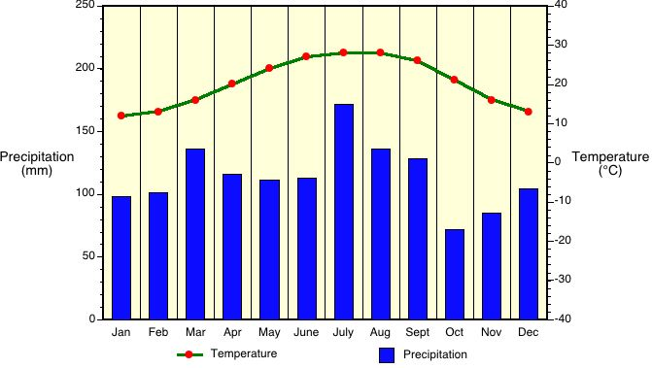
Temperature:__________________________
Precipitation:__________________________

- Biome:________________________________
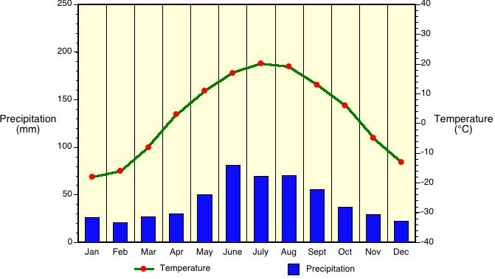
Temperature:__________________________
Precipitation:__________________________

- Biome:________________________________
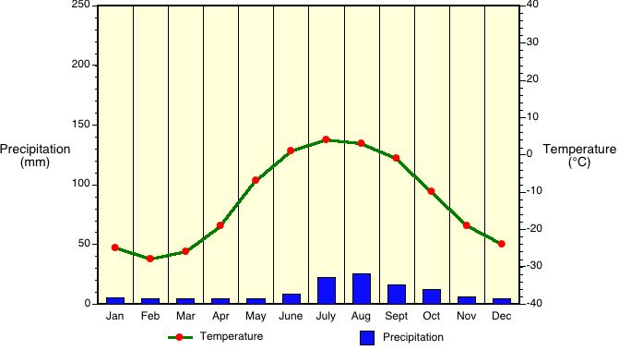
Temperature:__________________________
Precipitation:__________________________

- Biome:________________________________
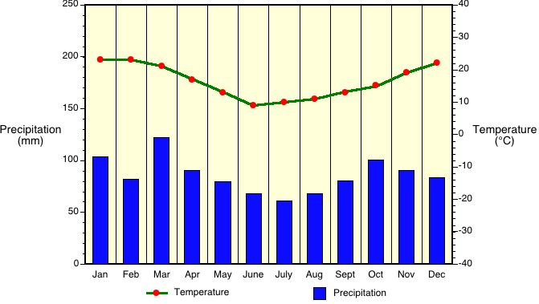
Temperature:__________________________
Precipitation:__________________________

