Density Layering Activity

Objective: Understand how salinity and temperature affect the density of water.
Hypothesis:
Your Hypothesis Goes Here:
Least Dense

Most Dense
Put in order from most dense to least dense:
- Tap water at room temperature (CLEAR)
- Salt water at room temperature (YELLOW)
- Cold water (BLUE)
- Hot water (RED)

Procedure:
- Place one end of your clear plastic box onto the textbook so it is tilted.
- From sink, measure 800 mL of tap water at room temperature in large beaker.
- Pour 800 mL of clear tap water into box.
- Obtain 40 mL salt water at room temperature. from teacher.
- SLOWLY pour salt water into the HIGH END of the plastic box.
- WATCH what happens by viewing at eye-level from the side. Describe what occurs. ______________ __________________________________________________________________________________
- Obtain 40 mL cold water. from teacher.
- Predict what will happen when you pour the cold water into the box. ________________________ _________________________________________________________________________________
- SLOWLY pour cold water into the HIGH END of the plastic box.
- WATCH and DESCRIBE what happens. ___________________________________________________ __________________________________________________________________________________

- Obtain 40 mL hot water. from teacher.
- Predict what will happen when you pour the hot water into the box. ___________________________ ___________________________________________________________________________________
- SLOWLY pour.
- WATCH and DESCRIBE what happens. ____________________________________________________ ___________________________________________________________________________________

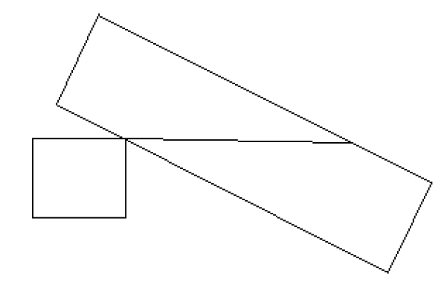
- Use colored pencils to fill in the diagram below, show the relative positions of each of the solutions in the box:
Results:

Least Dense

Most Dense

Analysis:
- What is density?

- Which factor has the greater effect on density? temperature/salinity
- How did your layers demonstrate this?

- How would an increase in evaporation affect the density of ocean water?

- Draw what a beaker of salt water would look like before and after an increase in evaporation (use dots to represent salt molecules):
After
Evaporation
Before

- Why does the density of liquid water increase as it cools?

- When seawater freezes in Polar Regions, most of the salt is left behind. How would this effect the density of the water that is left unfrozen?

- Based on what you have learned today, why does ice float in seawater? (think of icebergs)

