Lab: Density Layering

Objective: Understand how salinity and temperature affect the density of water.
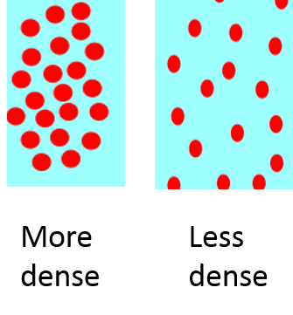
Background:
Density describes how compact the particles in an object are. The denser the object, the less space there is between particles, so it is more compact. This is shown below with two microscopic images of the particles within objects of different densities.

Hypothesis:
Your Hypothesis Goes Here (use TYPE of water, NOT COLOR):
Least Dense

Most dense
Most Dense
Put in order from most dense to least dense:
- Room temperature freshwater (CLEAR)
- Salt water at room temperature (YELLOW)
- Cold freshwater (BLUE)
- Hot freshwater (RED)

Procedure:
- Place one end of your clear plastic box onto the textbook so it is tilted.
- From sink, measure 800 mL of tap water at room temperature in large beaker.
- Pour 800 mL of clear tap water into box.
- Obtain 40 mL salt water at room temperature. from teacher.
- SLOWLY pour salt water into the HIGH END of the plastic box.
- WATCH what happens by viewing at eye-level from the side. Describe what occurs. ________________________________________________________________________________________________________________________________________________________
- Obtain 40 mL cold water. from teacher.
- Predict what will happen when you pour the cold water into the box. ________________________________________________________________________________________________________________________________________________________
- SLOWLY pour cold water into the HIGH END of the plastic box.
- WATCH and DESCRIBE what happens.
________________________________________________________________________________________________________________________________________________________
- Obtain 40 mL hot water. from teacher.
- Predict what will happen when you pour the hot water into the box. ________________________________________________________________________________________________________________________________________________________
- SLOWLY pour.
- WATCH and DESCRIBE what happens. ____________________________________________________________________________ ____________________________________________________________________________

Data:
Use colored pencils to fill in the diagram below, show the relative positions of each of the solutions in the box:
Results:

Least Dense

Most Dense

Textbook

Analysis:
- What is density?

- Which factor has the greater effect on density—circle one!

Temperature or Salinity

- How did your layers demonstrate your answer to #2?

- Identify how the density of ocean water would be affected by each of the following:
  - An increase in precipitation ________________
  - An increase in evaporation (hint: only the water evaporates, not the salt) ________________
  - The formation of sea ice (hint: only the water freezes, not the salt) ________________

- Draw what a beaker of salt water would look like before and after an increase in evaporation (use dots to represent salt molecules):
After
Evaporation
Before

- Why does the density of liquid water increase as it cools?

- Based on what you have learned today, WHY does ice float in seawater? (think of icebergs)

