Name: _________________________________________ Date: __________________ Class: __________

Designing for Disaster Activity

Objectives: Investigate how engineers design buildings and structures to withstand earthquakes.
Materials: Computer with Internet access.
Procedure:
- Go to National Geographic’s Forces of Nature site:
https://www.nationalgeographic.org/interactive/forces-nature/.
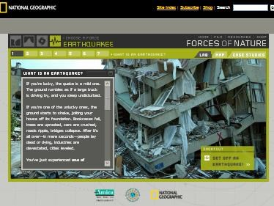
- From the Forces of Nature page, go to the Earthquakes tab by clicking on the Earthquakes icon (4th at top).
- Read and follow the instructions ON ALL 6 tabs/pages at the top. RAISE your hand once you have completed Tab 6 (do NOT close the tab—I need SEE your triangulated earthquake epicenter).
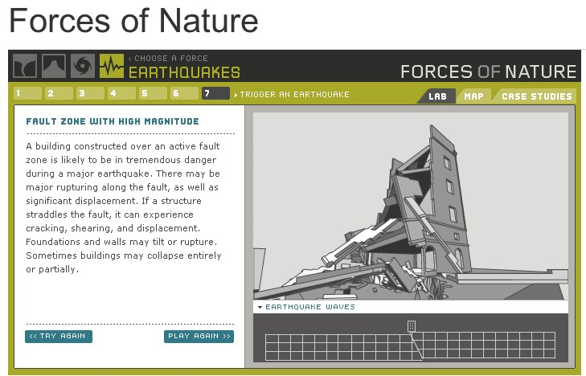
- Go to Tab 7. Complete all 6 possible combinations of ground type and magnitude (use “Try again” to set up a new combination), reading the descriptions of what is happening each time, and record a brief description of the damage from each combination in the table below.
Combination | Ground Type | Magnitude | Description of Damage
1
2
3
4
5
6
- From the simulation tests, which ground type results in the least amount of damage to the building regardless of magnitude?

- From the simulation tests, which scenario (combination of ground type and magnitude) results in the most amount of damage to the building?

- Go the San Francisco Earthquakes Living Lab: http://www.exploratorium.edu/faultline/damage/building.html.
- Read the article, “Damage Control: Engineering”.
- From the simulations you did in step 5 and what you have read, answer the following question:
  - If you were to design a building in an earthquake area, what design features would you incorporate to minimize the amount of damage? List at least 3.
    - _________________________________________________________________________

    - _________________________________________________________________________

    - _________________________________________________________________________
  - Overall, thoroughly compare the impact of seismic waves on structures built on solid rock vs. on softer soils. Use specific information from the websites you have visited today!

