Screening | Water from river, reservoir, or well – remove leaves, twigs and other large objects
Because these objects would clog the filters and machinery used in the rest of the treatment process (does not affect water quality) | 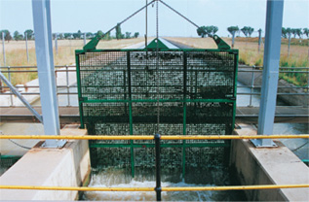
Coagulation | Chemicals added to cause small sediment to stick together, forming flocs (clumps of sediment)
Because this process makes it easier to remove/filter sediment when it is clumped together | 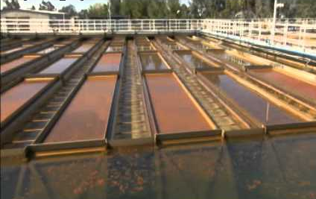
Sedimentation | Gravity causes sediment/flocs to settle at the bottom of the tank and surface water is moved to a clean tank
Because water with sediment is unappetizing, sediment can carry contaminants (chemical & biological) and sediment can shield contaminants during disinfection process | 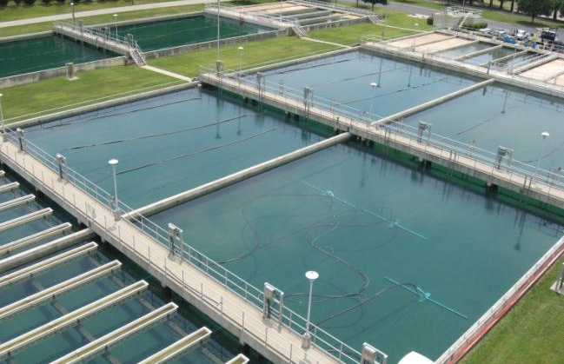
Filtration | Removes chemical and biological contaminants
Chemical contaminants can create bad smells and even disease if consumed. Biological contaminants can cause disease. | 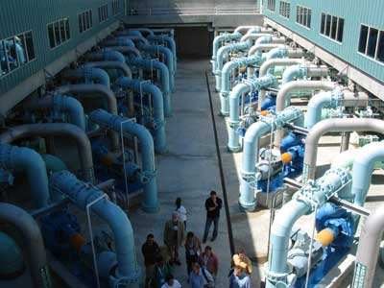
Disinfection | Chemicals (mainly chlorine) added to kill micro-organisms such as bacteria and followed by neutralization of any excess
Because it kills the bacteria that could cause disease | 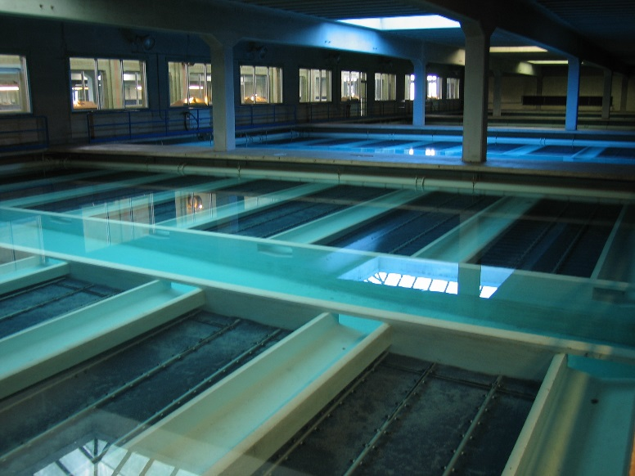
Storage | Water is kept in tanks until piped/pumped out to the community
Treatment process takes time, allows for quick access to vital resource | 