Name: ______________________________________
Why Do We Always See the Same Side of the Moon?
Introduction: Have you ever noticed that the pattern of light and dark spots (forming a “man” or “rabbit” in the moon) is the same all the time, no matter what phase the moon is in? This is because, from Earth, we can only see one side of the moon. The other side of the moon is always turned away from us—refer to the photograph of the far side and near side of the moon below.
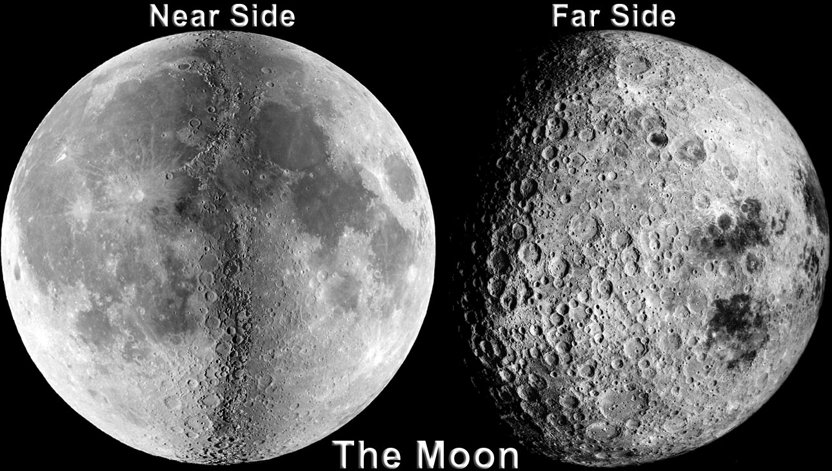
Materials: Two people and Photograph of the “near” and “far” sides of the moon
Activity: Examine the photographs of the “near” and “far” sides of the moon; note how unfamiliar the “far” side of the moon looks. Choose one person to model the moon and one to model Earth. Both people stand up, the “moon” revolves around “Earth” so that “Earth ” can only see the “moon's” face, never the back of the “moon's” head.
Questions: Answer in complete sentences.
- For each 360° revolution of the “moon” around “Earth,” how many times did the “moon” rotate (spin about its axis) 360°? Explain.

- What would happen if the “moon” did not rotate (e.g. always faced the front of the classroom) as it revolved around “Earth?”

- Does the real moon rotate? If so, how long does it take to complete one 360° rotation? Explain the reasoning behind your answer. (you may use an electronic device to help you with this questions)

Name: ______________________________________
What Causes Solar and Lunar Eclipses?
Materials: White polystyrene ball 3 inches in diameter (to represent the moon), Pencil or other “stick”, Glowing light bulb (to represent the sun)
Activity: Hold the ball out in front of you, but hold it level with your eye. Face the light bulb and hold the ball so that it blocks the light; it may help to close one eye.
Question:
- What kind of eclipse are you modeling?

More Activity: Now face away from the light bulb and hold the ball so that the shadow of your head covers the ball.

Question:

- What kind of eclipse are you modeling?

- Describe what causes a lunar eclipse. Draw a diagram to illustrate your answer.

- Describe what causes a solar eclipse. Draw a diagram to illustrate your answer

