Name: __________________________________________________ The Young Scientist Program - Teaching Kits
http://ysp.wustl.edu

Washington University School of Medicine
Funding provided by The Leon Lowenstein Foundation
Modified by PCHS Spring 2017

Ecological Interactions Lab
Background

A niche is the way of life of a species, or its role in an ecological community (what it eats, where it lives, how it interacts with other species, etc). For example, the niche of a honey bee is the time of day it is active, the type of flowers it gets nectar from, the temperature range it can survive, where it builds its hive, which other species it interacts with, and how it interacts with those other species (mutualism, parasitism, commensalism, etc). Another way of thinking about a niche is that it is the sum of the biotic (living) and abiotic (nonliving) resources that a species uses.

Species do not live by themselves—they live in ecological communities and are constantly interacting with other species. Something that affects one species will impact all the other species it interacts with. For example, if a frog species goes extinct in a community, then the snakes that usually eat it will have to find another food source or they will go extinct as well. And since there are no more frogs left to eat the moths, the moth population might increase so dramatically that it becomes out of control and eats all of the plants in the community, leaving no food for other plant eaters.

Species can have many different types of interactions with each other, some interactions help both species, some help just one of the species, and some can be negative for one or both of the species. All of these interactions are needed to maintain balance in an ecosystem. Symbiosis means “to live together,” and happens when two species have a close relationship with each other. Interactions that fall under the category of symbiosis are mutualism, parasitism, and commensalism.

Parasitism is an interaction that harms one species and benefits the other species. A parasite lives on or in a host organism. For example, tarantula wasps lay eggs in tarantulas. This benefits the wasps because the larvae eat the tarantula’s tissues, killing the tarantula. Other types of interactions that harm one species and benefit the other are predation (a predator eats its prey) and herbivory (the consumer eats a plant species - producer).

Competition is an interaction that harms both species. Two species are competing for a limited resource. This reduces the fitness of one or both of the species. For example, hyenas chase away vultures that are trying to eat the remains of the same zebra.

Mutualism is a type of interaction where both species benefit each other. For example, bees and flowers have a mutualistic relationship. The flowers need to bees to pollinate them so their seeds can be fertilized. Bees need flowers to make honey for their hives.

Commensalism is an interaction that benefits one species and does not affect the other species at all. For example, while cattle graze in fields they unintentionally stir up insects that were resting in the grass. Cattle egrets follow the cows’ paths and eat these insects. The egrets benefit because cows help them find food. The cows are not benefitted or harmed by the egrets.
Key Stone Species is a plant or animal that plays a unique and crucial role in the way an ecosystem functions. A keystone species is often, but not always, a predator. A few predators can control the distribution and population of large numbers of prey species. For example, a single mountain lion can roam an area of hundreds of kilometers. The deer, rabbits, and bird species in the ecosystem are at least partly controlled by the presence of the mountain lion. Their feeding behavior, or where they choose to make their nests and burrows, are largely a reaction to the mountain lion's activity.
Apex predator is a predator residing at the top of a food chain upon which no other creatures prey, like polar bears, wolves, sharks and crocodiles.
Some species are generalists, meaning they can eat many different types of foods. Raccoons are generalists, since they can eat many different foods such as eggs, bugs, nuts, birds, and berries. Other species are specialists, meaning they eat only a certain type of food. Koalas are specialists, since almost their entire diet is eucalyptus leaves.

Procedure:
  - Complete the introduction portion of the activity.
  - M&M Activity
    - Students will be in groups of 3. Each student is a different species (Species A, B and C).

    - Each group gets a bowl of M&Ms. Each student gets a spoon, cup, and set of note cards.

    - For each round, students read the instructions on their note card about how they can survive the winter. Students should keep their instructions hidden from other group members.
    - With the bowl of M&Ms in the center of each group. Students will use a spoon to collect M&Ms and place them into their cups. No stealing from other student’s cups unless your instructions tell you to do so.

    - Each round lasts 1 minute (or less). At the end of the round, students should record how many M&Ms each species collected, then return the M&Ms to the community bowl and answer questions.
Introduction
A niche is: ____________________________________________________________________
How is a species niche different than its habitat?

Interaction | Species 1 | Species 2 | Definition | Example
- Parasitism (parasite lives on or inside of a host)  - Predation (predator eats prey)  - Herbivory (organism eats a plant species) |  |  |  | 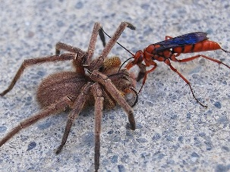  Tarantula wasps lay eggs inside of tarantulas while they’re still alive
Mutualism |  |  |  | 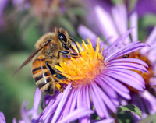  Bees pollinate flowers
Competition |  |  |  | 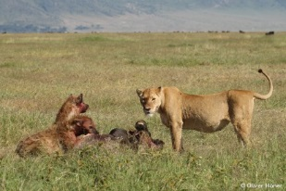  Hyenas and lions both try to eat the same prey
Commensalism |  |  |  | 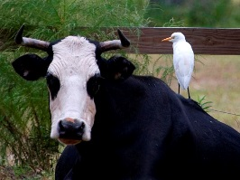  Egret birds eat insects that cows & horses disturb
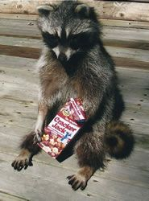
A generalist is a species that can eat many different types of foods. For example, raccoons eat many things, including human garbage!

List another example:

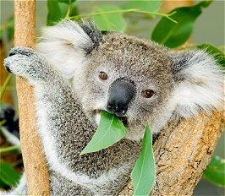
A specialist is a species that eats only a certain type of food. For example, koalas only eat eucalyptus plants.

List another example:

Activity Instructions:

Each person in your group represents a different species (Species A, Species B, and Species C), so each person gets a different stack of cards. Don’t let anyone else see the instructions on your card, or they’ll have a better chance of beating you!

Put the bowl of M&Ms in the center of your group, and give each group member a spoon. Use the spoon to collect M&Ms—only one at a time. Leave your cup on the table, not in your hand. No cup guarding! At the end of the round, count how many M&Ms you collected, fill out the table, and answer the related questions. Then, put all of your M&Ms back into the community bowl for the next round.

Round 1
 | Species A | Species B | Species C
Number of M&Ms in the cup
Did this species collect enough food to survive the winter?
- Which two species occupied the same niche in this community? How do you know?

- Which ecological relationship does…
  - …Species A and Species B have?
( mutualism / parasitism / competition / commensalism / none )

  - …Species A and Species C have?
( mutualism / parasitism / competition / commensalism / none )

  - …Species B and Species C have?
( mutualism / parasitism / competition / commensalism / none )

- Why will two species not be able to occupy the same niche in a community for very long?

- Was your species a generalist or a specialist? Why?

Round 2
 | Species A | Species B | Species C
Number of M&Ms in the cup
Did this species collect enough food to survive the winter?

- Which ecological relationship does…
  - …Species A and Species B have?
( mutualism / parasitism / competition / commensalism / none )

  - …Species A and Species C have?
( mutualism / parasitism / competition / commensalism / none )

  - …Species B and Species C have?
( mutualism / parasitism / competition / commensalism / none )

- Was your species a generalist or a specialist? Why?

Round 3
 | Species A | Species B | Species C
Number of M&Ms in the cup
Did this species collect enough food to survive the winter?

- Which ecological relationship does…
  - …Species A and Species B have?
( mutualism / parasitism / competition / commensalism / none )

  - …Species A and Species C have?
( mutualism / parasitism / competition / commensalism / none )

  - …Species B and Species C have?
( mutualism / parasitism / competition / commensalism / none )

Round 4
 | Species A | Species B | Species C
Number of M&Ms in the cup
Did this species collect enough food to survive the winter?

- Which ecological relationship does…
  - …Species A and Species B have?
( mutualism / parasitism / competition / commensalism / none )

  - …Species A and Species C have?
( mutualism / parasitism / competition / commensalism / none )

  - …Species B and Species C have?
( mutualism / parasitism / competition / commensalism / none )

Analysis Questions
- If the environment changed suddenly, for example because of global warming, do you think generalist or specialist species would be better able to adapt and avoid going extinct? Why?

- What would happen if an invasive species came into your ecosystem that ate blue, red, and orange M&Ms and was better at collecting food than all three of your species?

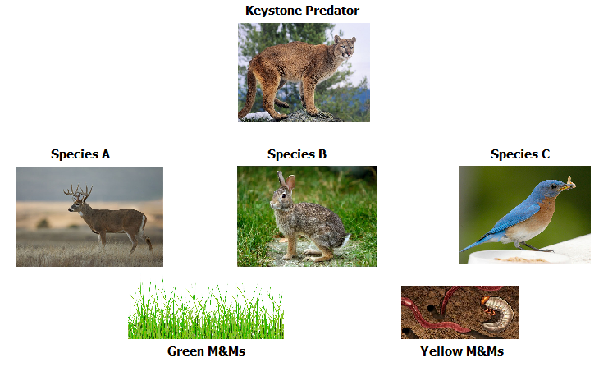
- If in Round 1 Species A and B were both herbivores that were preyed upon by a keystone predator, how would the removal of that keystone predator affect the ENTIRE ecosystem? Be specific. Use the food web for Round 1 to help you answer.

The Young Scientist Program - Teaching Kits
http://ysp.wustl.edu

Washington University School of Medicine
Funding provided by The Leon Lowenstein Foundation

Ecological Interactions Activity
Teacher Guide

Round 1 | Round 1 | Round 1
Species A | Species B | Species C

Round 2 | Round 2 | Round 2
Species A | Species B | Species C

Round 3 | Round 3 | Round 3
Species A | Species B | Species C

Round 4 | Round 4 | Round 4
Species A | Species B | Species C

The Young Scientist Program - Teaching Kits
http://ysp.wustl.edu

Washington University School of Medicine
Funding provided by The Leon Lowenstein Foundation

Ecological Interactions Activity
Teacher Guide

ROUND 1--SPECIES C | ROUND 1--SPECIES B | ROUND 1--SPECIES A
What you need to do to survive: | What you need to do to survive: | What you need to do to survive:
You can eat yellow M&Ms. All | You can only eat green M&Ms. | You can only eat green M&Ms.
other colors of M&Ms will make | All other colors of M&Ms will | All other colors of M&Ms will
you sick. You must collect at | make you sick. You must collect | make you sick. You must collect
least 6 yellow M&Ms to survive | at least 6 green M&Ms to survive | at least 6 green M&Ms to survive
the winter. | the winter. | the winter.

ROUND 2--SPECIES C | ROUND 2--SPECIES B | ROUND 2--SPECIES A
What you need to do to survive: | What you need to do to survive: | What you need to do to survive:
You can eat any color M&Ms, | You can eat green and orange | You can red and blue M&Ms.
but you can only eat those that | M&Ms. You need at least 6 | You need at least 6 M&Ms to
Species A or B have put into their | M&Ms to survive the winter. If | survive the winter. If another
cups (take them gently please). | another species tries to take your | species tries to take your M&Ms,
You need at least 6 M&Ms to | M&Ms, you cannot stop them. | you cannot stop them. No cup
survive the winter. | No cup guarding. | guarding.

ROUND 3--SPECIES C | ROUND 3--SPECIES B | ROUND 3--SPECIES A
What you need to do to survive: | What you need to do to survive: | What you need to do to survive:
You need 2 blue, 2 orange, and 2 | You need 2 blue, 2 orange, and 2 | You need 2 blue, 2 orange, and 2
red M&Ms to survive winter. | red M&Ms to survive winter. | red M&Ms to survive winter.
Unfortunately, you can only pick | Unfortunately, you can only pick | Unfortunately, you can only pick
up orange M&Ms. Species A and | up red M&Ms. Species A and C | up blue M&Ms. Species B and C
B will have to help you out for | will have to help you out for the | will have to help you out for the
the blue and red M&Ms. After | blue and orange M&Ms. After | orange and red M&Ms. After
picking up your 2 orange M&Ms, | picking up your 2 red M&Ms, put | picking up your 2 blue M&Ms,
put 2 orange M&Ms in both | 2 red M&Ms in both Species A | put 2 blue M&Ms in both Species
Species A and B’s cups. | and C’s cups. | B and C’s cups.

ROUND 4--SPECIES C | ROUND 4--SPECIES B | ROUND 4 --SPECIES A
You can eat blue and green | You can eat blue and green | You can eat red and orange
M&Ms. Red M&Ms are | M&Ms. Red M&Ms are | M&Ms. You must collect at least
dangerous to your children, so | dangerous to your children, so | 6 M&Ms to survive the winter.
you should remove them from the | you should remove them from the
bowl before collecting the blue | bowl before collecting the blue
and green M&Ms. Put red | and green M&Ms. Put red
M&Ms in Species A’s cup. You | M&Ms in Species A’s cup. You
must collect at least 6 M&Ms to | must collect at least 6 M&Ms to
survive the winter. | survive the winter.

