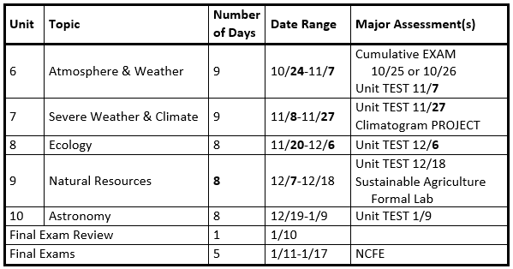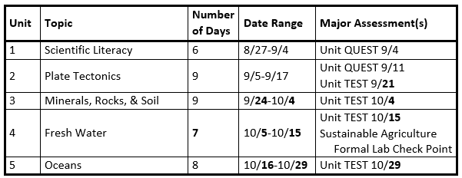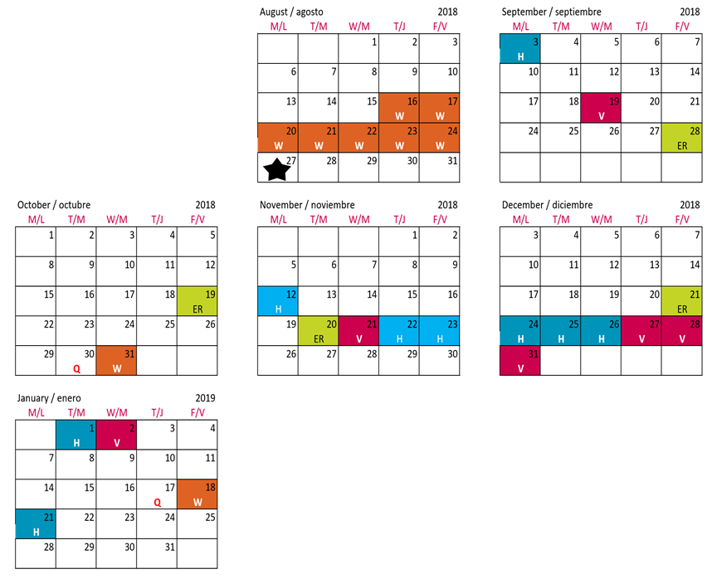

**U8 TEST**

**U7 TEST**

**U6 TEST**

**U5 TEST**

**U4 TEST**

**U3 TEST**

**U2 TEST**

**Cumulative TEST**

**Final Exams**

**Final Exams**

**Final Exams**

**Final Exams**

**Final Exams**

**U10 TEST**

**U9 TEST**

**U2 QUEST**

**U1 QUEST**

Earth/Environmental

Science 9th Grade

Fall 2018

Updated 9/20 post Hurricance Florence