Cold  Front | Warm Front | Stationary Front | Occluded Front
A mass of cold air moves into an area of warm air and pushes the warm air out | A mass of warm air moves into an area of cold air and pushes the cold air out | Two masses of air, one cold and one warm, collide while moving in opposite directions and neither is able to push the other aside for several days | A mass of warm air is caught between two masses of cold air; all move in the same direction but the last cold air mass, moving the fastest, slides underneath the warm air and forces it up off of the ground, trapping it above the two cool air masses
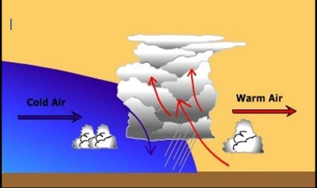 | 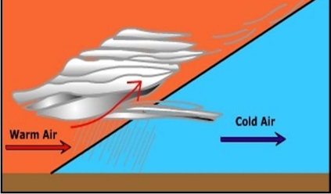 | 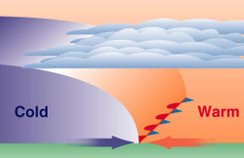 | 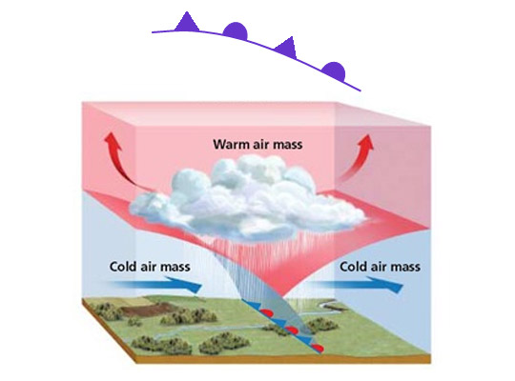
Weather Before:  Warm & Cloudy | Weather Before:  Cold & Fair/Clear | Weather Before:  Cool & Clear/Fair  OR  Warm & Cloudy | Weather Before:  Warm & Cloudy
Weather During:  Thunderstorms | Weather During:  Rain | Weather During:  Several Days of Light Rain | Weather During:  Light Rain
Weather After:  Cool & Clear/Fair | Weather After:  Warm & Cloudy | Weather After:  Cool & Clear/Fair  OR  Warm & Cloudy | Weather After:  Cool & Clear/Fair
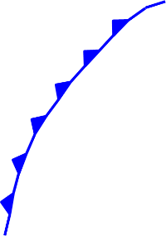 |  | 