Name: ________________________________________________ Date: __________________ Period: ________

Practice with Graphs

Well-drawn graphs always include:
- Overall Title: tells the reader what data they will review
- Labels for both the x and y axis: tells what information is found on that axis and includes the units (for example: water (L), or distance walked (m))
- Key/Legend: if more than one variable is graphed, it is best to differentiate them with colors or shapes
- Scale: each axis of the graph should be drawn with even spaces between units

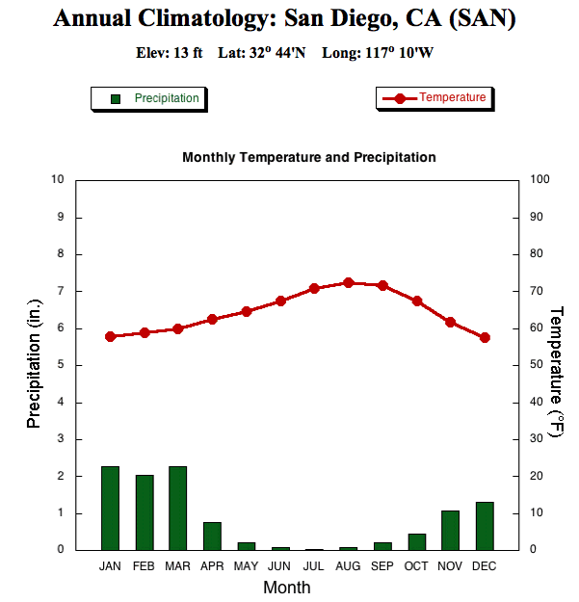
Example:

Directions: Graph the data provided on the graphing space below. Incorporate all of the aspects listed above to make them well-drawn graphs.

Injuries | Occurrence per Year
Heat Burns | 20
Cuts & Scrapes | 80
Spills & Breaks | 180
Fire | 10
- Graph #1:
  - Determine the best type of graph to use with the following data on common injuries that occur in a high school science laboratory: ______________
  - Create the graph.

  - Explain the results of the graph in a sentence or two referencing the data from the types of injuries.

  - Provide one way to prevent the most common type of injury.

- Graph #2
  - Determine the best type of graph to use with the following data on bacterial growth: __________
  - Create the graph.
Days | # of Bacteria
1 | 28
2 | 45
3 | 64
4 | 100
5 | 175
6 | 240
7 | 350
8 | 400
9 | 425
10 | 500

  - Describe what happens to the
rate of bacteria growth over time.

  - WHY might this be happening?

