Name: _______________________________________________ Date: ___________________ Period: ________
Chapter 5 Weathering, Soil, and Mass Movements
Section 5.3 Mass Movements
This section describes situations in which large amounts of soil are moved naturally.
Triggers of Mass Movements
- The transfer of rock and soil downslope due to ________________________ is called mass movements.
- Circle the letter of each sentence that is true about water triggering mass movements.
  - Heavy rains and rapid melting of snow can trigger mass movements by saturating surface material with water.
  - When the pores in sediment become filled with water, the particles slide past one another more easily.
  - If there is sufficient water, sand grains will slowly move downhill.
  - Saturation of the ground with water make slopes less susceptible to the force of gravity.
- Is the following sentence true or false? If the steepness of a slope is increased, mass movements become more likely. ___________________________
Types of Mass Movements
Match each description with its term.

Description
- _____ A flow that moves very slowly – from about a millimeter per day to several meters per day due to alternate freezing and thawing of the ground
- _____ The downward movement of a block of material along a curved surface
- _____ A quickly moving mass of material that contains large amounts of water
- _____ When rock or rock fragments fall freely through the air
- _____ Mass movements that include bedrock that move suddenly along a flat, inclined surface
Term
  - Falls
  - Slides
  - Slump
  - Flows
  - Creep

- Identify each of the forms of mass movements illustrated in the figures below by writing the name of the process on the lines provided.
Choose creep, slump, falls, or slides

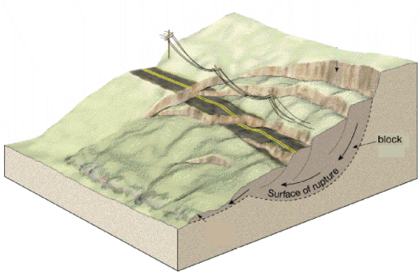
- ___________________ B. ____________________ C. ____________________ D. __________________
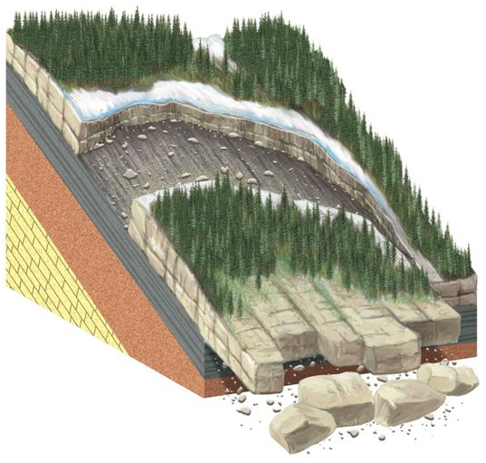
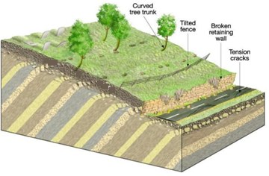
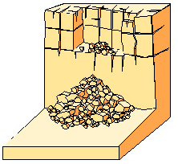
D
C
B
A

