Unit 5 Notes: Moderation of Coastal Climates

Oceans as Energy Transporters: Warm Currents
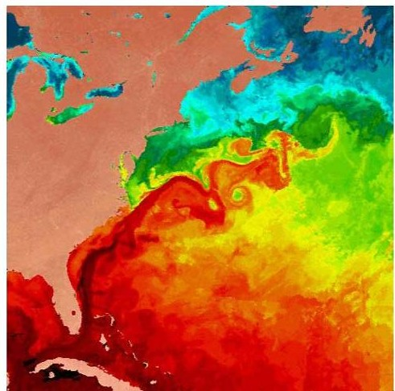
- ________________________________________________

________________________________________________
- Warm Currents:
  - ___________________________________________

___________________________________________

  - ___________________________________________

___________________________________________

Oceans as Energy Transporters: Cold Currents
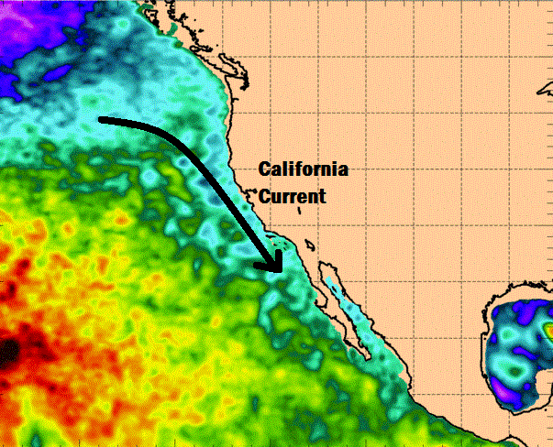
- Cold Currents:
  - ___________________________________________

___________________________________________

  - ___________________________________________

___________________________________________

Oceans as Energy Transporters: Example
- ________________________________________________________________________

________________________________________________________________________

  - ___________________________________________________________________

  - ___________________________________________________________________

Oceans as Heat Sinks
- Heat sinks . . .
  - ___________________________________________________________________

  - ___________________________________________________________________

    - _____________________________________________________________

_____________________________________________________________

    - _____________________________________________________________

_____________________________________________________________

    - _____________________________________________________________

_____________________________________________________________

Heat Sinks and Climate: Temperature Change
- ________________________________________________________________________

- ________________________________________________________________________

________________________________________________________________________

- ________________________________________________________________________

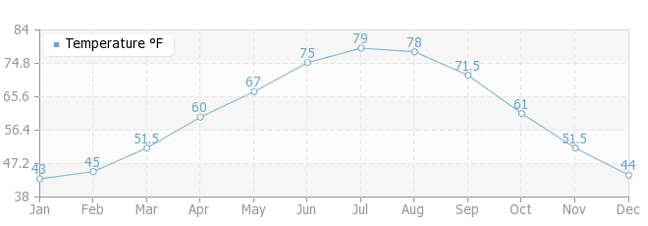
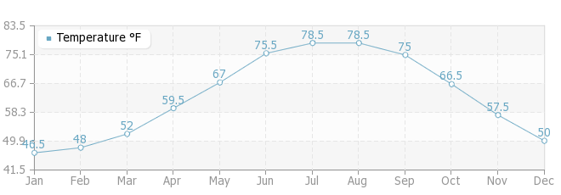
________________________________________________________________________

  - _________________________________

_________________________________

_________________________________
Raleigh
Outer Banks

  - _________________________________

___________________________________________________________________

Heat Sinks and Climate: Temperature Modification
- ________________________________________________________________________

________________________________________________________________________

