Rock Cycle Interactive Notes
Access this website: https://www.learner.org/interactives/rockcycle/index.html
- Types of Rocks
  - Rocks are not all the same!
Read the information and take notes in the table below.
Type | Formation | Characteristics | Examples

  - What to Look For:
    - _______________________________
    - _______________________________
    - _______________________________
    - _______________________________
    - _______________________________ (also called foliation)
    - _______________________________

  - Rock Collection
Complete the activity online and record the information in the table below.
Name | Characteristics | Type

  - Identify Rock Types
Complete the questions online and record the correct answers below.
Rock Shown | Characteristic Identified | Rock Class
Marble
Conglomerate
Obsidian
Limestone
Gneiss

- How Rocks Change
  - Heat & Pressure
Read the information, play the animation, and take notes below.
- Metamorphism:

  - Melting & Cooling
Read the information, play the animations, and take notes below.
- Extrusive (small grains/crystals):

- Intrusive (large grains/crystals):

  - Weathering, Erosion, Compaction, & Cementing
Read the information, play the animations, and take notes below.
- Weathering:

- Erosion:

- Accumulation/Deposition:

- Compaction:

- Cementing:
  - Transform the Rock
Complete the online activity and record the correct answers below.
1. The conglomerate has disappeared! What can turn pebbles and sand (sediment) into a conglomerate (sedimentary rock)?

2. The marble is gone! What process can turn limestone (sedimentary rock) into marble (metamorphic rock)?

3. What happened to the obsidian? It’s turned into sand! What process can turn obsidian (igneous rock) into sediment?

4. The gneiss got pushed way underground! What process can turn gneiss (metamorphic rock) into magma?

5. Over time, magma deep inside the earth has turned into granite (igneous rock). What process made this happen?

6. The granite has slowly been pushed to the surface of the earth, where wind and water have worn it down. What is the name of the process that turned granite into sediment?

7. Over time, the sandy sediment has become a sedimentary rock called sandstone. What process turns sand into sandstone?

8. Next the sandstone gets pushed underground and transforms into a metamorphic rock called quartzite. What process can turn sandstone into quartzite?

9. Finally, the quartzite gets pushed even farther under the surface of the earth, where it becomes magma. What turns quartzite into magma?

- The Rock Cycle Diagram
  - The Rock Cycle
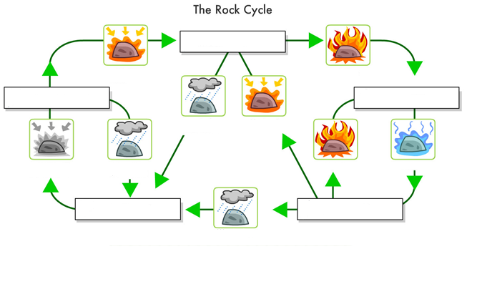
Explore the online diagram and complete the one shown below. Be sure to record to record the process name(s) below each image!

  - Complete the Cycle
Answer the questions online and record the correct responses below.
1. When rocks are affected by weathering and erosion, the change into which of the following?

2. When sediment is compacted and cemented, it changes into which of the following?

3. When heat and pressure are applied to a sedimentary rock, it changes into which of the following?

4. When melting of a metamorphic rock occurs, it changes into which of the following?

5. When magma is cooled, it changes into which of the following?

- Test Your Skills
Enter your name online then take the 15 question quiz. When finished, raise your hand for me to record your score, or snip/screen shot your final score (including your name) and email it to me.

