Sea Level Change
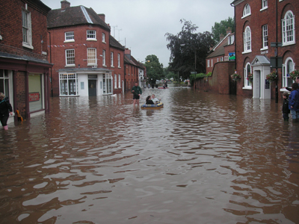
Make a line graph on the paper
provided using the data below:
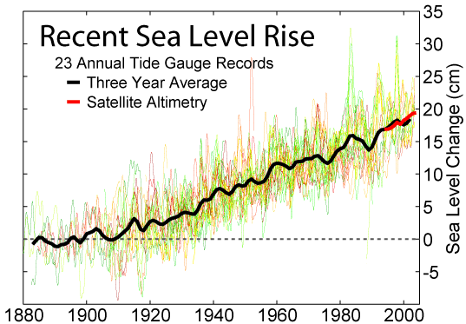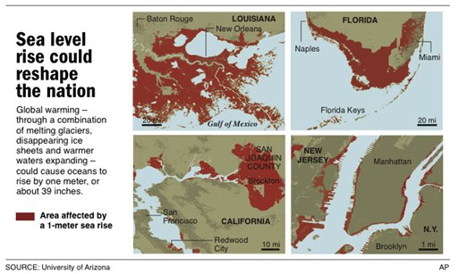
Using your graph and the one provided above, answer the following questions in complete sentences on the back of this sheet or your own paper:
- In the last 148,000 years, when was the sea level lowest?
- Aside from the present time, when was sea level highest?
- Looking at the graph provided above, estimate the amount of sea level rise over the last 20 years (as sea level rise per year).
- Climatologists at the USGS estimate that the sea level will rise 80 cm in the next century. More than 50% of the people in the U.S. live in coastal communities. What impact will sea level rise have on the U.S.?
- Give two possible causes of sea level rise 120 thousand years ago.
- Give two possible causes of current sea level rise.
- You are a realtor specializing in beach front property in Florida. What pressure can you bring on your elected officials to protect your livelihood?
Thousands of years ago | Sea Level (meters)  compared to today
0 | 0
7 | -24
15 | -124
20 | -95
33 | -75
38 | -78
40 | -80
41 | -77
45 | -80
48 | -82
50 | -60
54 | -75
58 | -57
61 | -76
70 | -73
75 | -70
79 | -58
85 | -35
90 | -38
92 | -35
95 | -37
100 | -26
105 | -55
110 | -53
115 | -5
120 | -2
125 | -60
130 | -52
140 | -132
142 | -127
144 | -132
146 | -125
148 | -140

