Formal Lab Report: Sustainable Agriculture

Problem:
How does the choice of agricultural techniques affect the ability of water bodies to support plant and animal life? (Copy as written here)

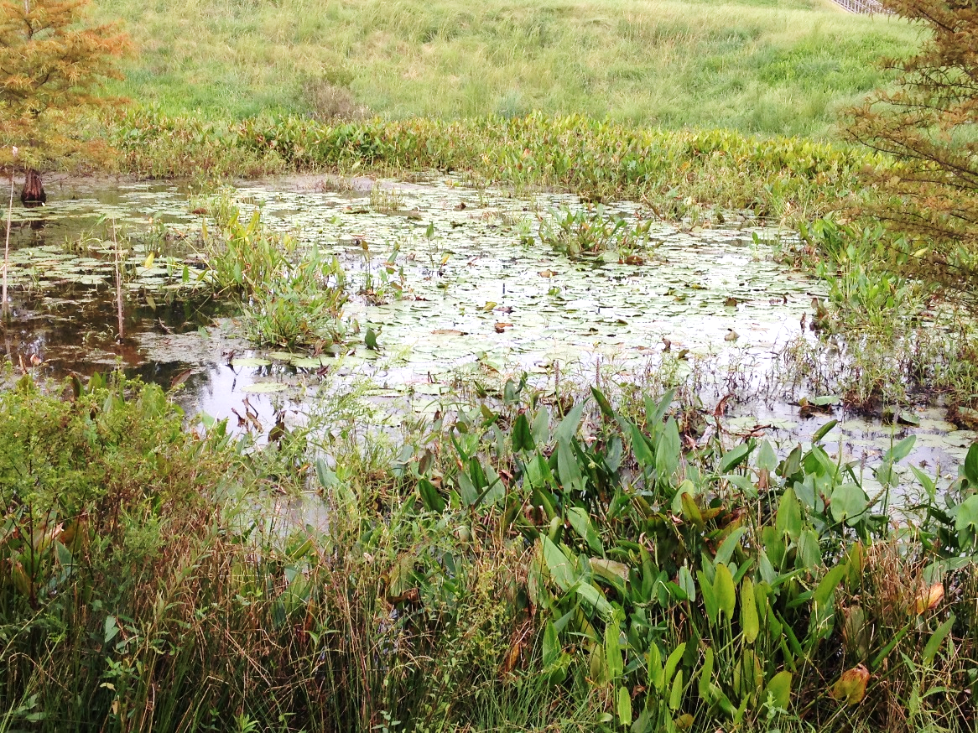
Background:
Site 1: PCHS Retention Pond Next to Mod 5

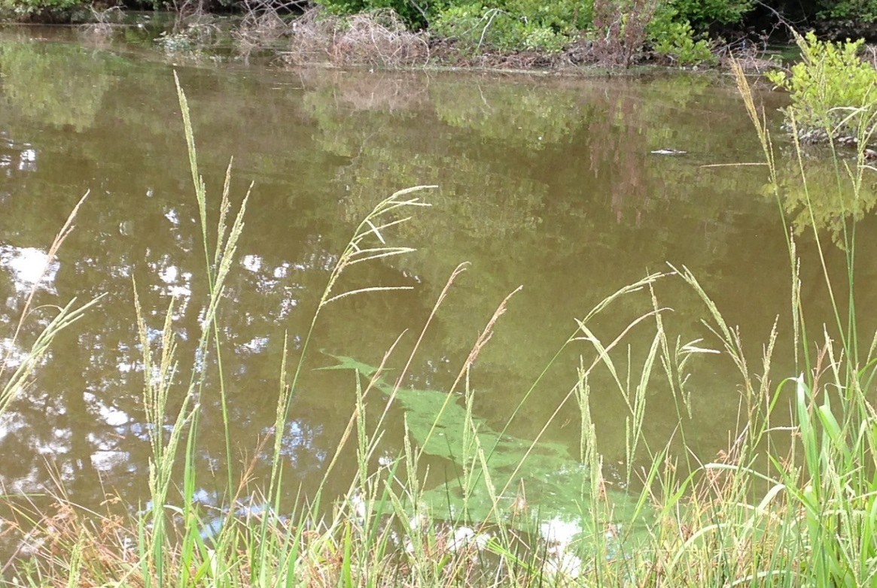
Site 2: Retention Pond from the Stockton Neighborhood in Angier, NC
Background paragraphs (5 sentences each—1 introductory, 3 body, and 1 conclusion)
Paragraph 1—Unit 3—Types of Farming (compare traditional versus no-till)
Paragraph 2—Unit 4—Erosion Tied to Turbidity & Eutrophication of Local Water Ways
Paragraph 3—Unit 5—Dead Zones in Gulf of Mexico
Paragraph 4—Unit 8—Effects on Biodiversity

Hypothesis:
Sustainability of Agriculture Near Site 1 (PCHS Retention Pond) vs. Site 2 (Stockton Neighborhood Retention Pond) based on the ability of the ponds to support plant and animal life (Ex: If the agricultural techniques are less sustainable near Site ___ than Site ___, then the pond at Site ___ will have a _______ level of dissolved oxygen and ________ levels of nitrates, phosphates, and turbidity than Site ___.)

Materials:
- LaMotte: Water Monitoring Kit (Copy as written here)
- Freshwater sample from retention pond (Copy as written here)

Procedure:
Physical, chemical and biological tests were completed using instructions included in the LaMotte: Water Monitoring Kit. Tests performed include: temperature, turbidity, dissolved oxygen (DO), percent saturation of dissolved oxygen, nitrate, phosphate, pH, coliform bacteria and looking for other life forms. (Copy as written here)

Data:
Site 1: PCHS Retention Pond Next to Mod 5
Physical Tests | Result (Include Units) | Ranking (Number AND Word)
Temperature
Turbidity

Chemical Tests | Result | Ranking
Dissolved Oxygen (DO)
Percent Saturation of Dissolved Oxygen
Nitrate
pH
Phosphate

Biological Tests | Result | Ranking
Coliform Bacteria
Other Life

Site 2: Retention Pond from the Stockton Neighborhood in Angier, NC (Copy as written here)
Physical Tests | Result (Include Units) | Ranking (Number AND Word)
Temperature | 18°C
Turbidity | 70 JTU | 2 (fair)

Chemical Tests | Result | Ranking
Dissolved Oxygen (DO) | 0 ppm
Percent Saturation of Dissolved Oxygen | 0% | 1 (poor)
Nitrate | 20 ppm | 1 (poor)
pH | 6 | 3 (good)
Phosphate | 4 ppm | 2 (fair)

Biological Tests | Result | Ranking
Coliform Bacteria | Positive | 1 (poor)
Other Life | Green algae

Analysis:
Natural Water Quality of Ponds
- Claim (1 sentence): Identify which site/pond has the worst natural water quality (lower ability to support plant and animal life).
- Evidence (1 sentence each):
  - Compare the turbidity results for the two ponds.
  - Compare the dissolved oxygen results for the two ponds.
  - Compare the nitrate results for the two ponds.
  - Compare the phosphate results for the two ponds.
- Reasoning (1-2 sentences each):
  - Use the quantitative turbidity data as well as the qualitative ranking to support your claim from above (the pond with the worst natural water quality).
  - Use the quantitative dissolved oxygen data as well as the qualitative ranking to support your claim from above (the pond with the worst natural water quality).
  - Use the quantitative nitrates data as well as the qualitative ranking to support your claim from above (the pond with the worst natural water quality).
  - Use the quantitative phosphates data as well as the qualitative ranking to support your claim from above (the pond with the worst natural water quality).
- Summary (2-3 sentences): Explain how the overall claim was decided even though the data points do not all have the same ranking.

Conclusion:
- Pond Most Affected by Sustainable Agricultural Practices
  - Claim (1 sentence each):
    - Identify which pond/site is most affected by non-sustainable agricultural practices (has the worst natural water quality).
    - Evaluate your original hypothesis—does the data support it or must you reject it?
  - Evidence (2-3 sentences):
    - Review the qualitative data for each site’s pond:
      - Turbidity
      - Dissolved Oxygen
      - Nitrates
      - Phosphates
    - Summarize the abilities of the ponds to support plant and animal life based on the qualitative data above.
  - Reasoning (2 sentences each):
    - Explain how non-sustainable agricultural techniques affect turbidity levels and in turn lowers natural water quality.
    - Explain how non-sustainable agricultural techniques affect dissolved oxygen levels and in turn lowers natural water quality.
    - Explain how non-sustainable agricultural techniques affect phosphate and nitrate levels and in turn lowers natural water quality.
  - Summary (1-2 sentences): Explain how the agricultural techniques used in an area affects the natural water quality of local water ways.
- Sources of Error—these are NOT mistakes that could have been corrected. These are limitations to your data based on factors outside of your control. Consider how the tests are designed, the way the water was collected, etc.
  - 1st source of error and how (specifically) it most likely affected your data.
  - 2nd source of error and how (specifically) it most likely affected your data.

