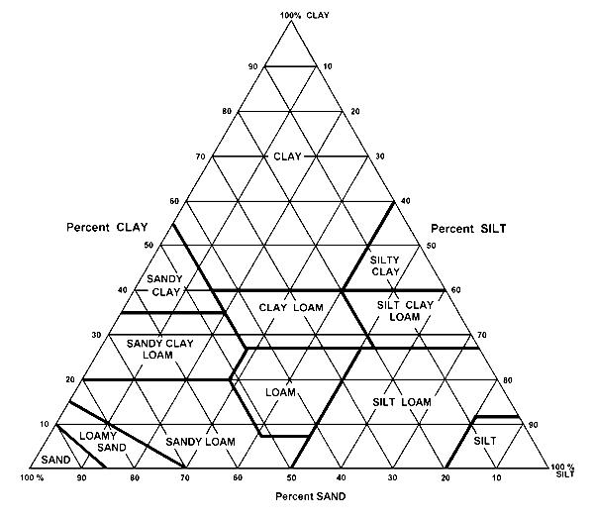
Soil Texture Triangle
% sand % silt % clay Soil Texture/Type

Example 75 10 15 sandy loam

- 42 _____ 37 __________________

- ______ 52 21 __________________

- ______ 35 50 __________________

- 64 30 ______ __________________

- 50 _____ 40 __________________

Now for a challenge!:

- 36 ______ ______ Clay Loam

- _____ ______ 42 Silty Clay

- _____ ______ ______ Loamy sand

- _____ ______ ______ Silt loam

