Solar Radiation Crossword Puzzle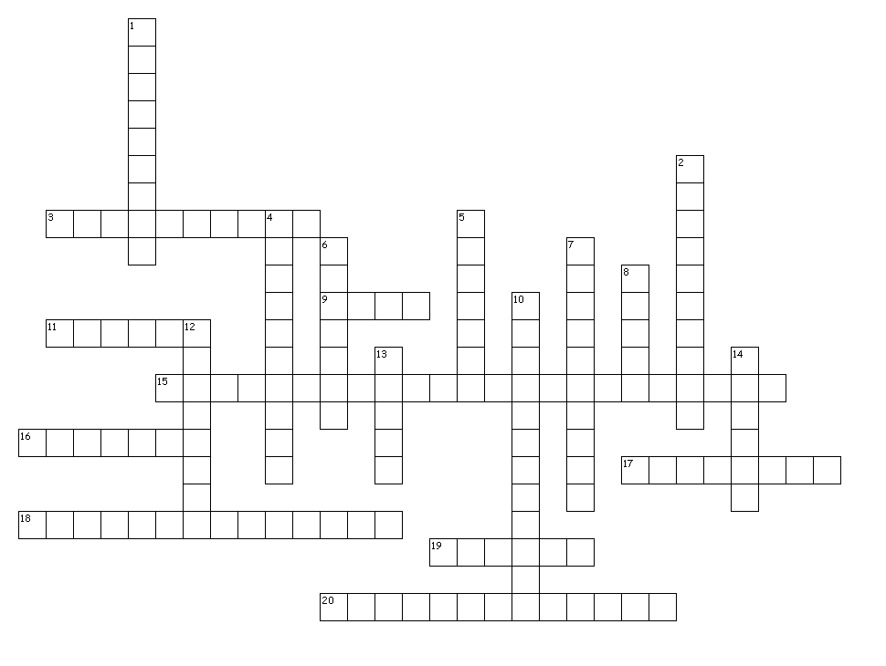
Across
3. Of the Earth's four spheres, this one is responsible for stopping incoming solar radiation
9. Our sun is an example of this celestial body
11. The element produced by the sun's nuclear reactions
15. The array of the various types of radiation that exist in our universe
16. The sun's ______ causes objects to orbit it
17. The element the sun uses to fuel its nuclear reactions
18. Solar radiation is converted from light energy into chemical energy during this process
19. The shape of our galaxy
20. Earth's __________ protects us from solar radiation by forcing the particles to move around Earth through space

Down
1. Another term for energy
2. The ___________ of other stars is measured relative to our sun
4. An object's orbit around the sun
5. The majority of solar radiation that reaches Earth is in this category
6. Nuclear reaction that produces heat when it creates two or more smaller atoms from a larger one
7. Burning of fuel that produces heat by rearranging the same atoms into a different pattern
8. The layer of the atmosphere responsible for stopping most solar radiation
10. A sun-centered solar system
12. Our sun is located inside an arm of this galaxy
13. This type of radiation reaching Earth's surface allows us to communicate with the International Space Station
14. Nuclear reaction that produces heat when it creates a larger atom from two or more smaller ones

