Practice: Solar Radiation
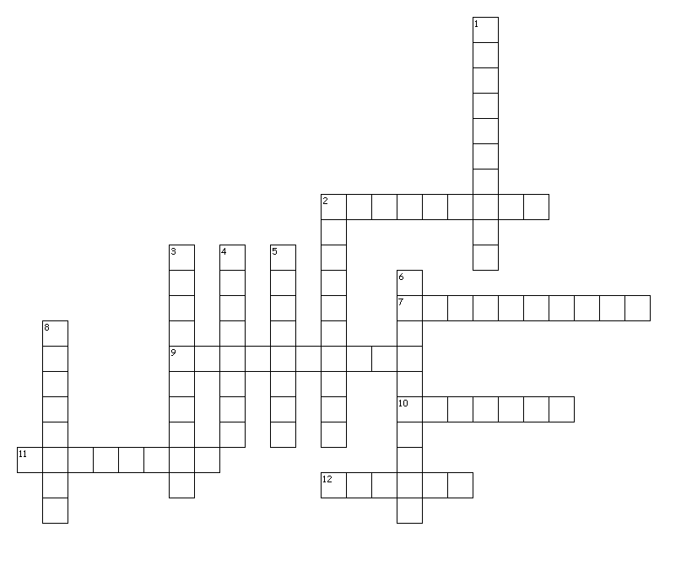

Across
2. Method of energy transfer by which Earth receives energy from the sun
7. Occurs when two air masses of different temperatures meet and exchange heat via mixing
9. The cause for our seasons
10. Term for when there are equal hours of day and night
11. The month of the winter solstice in the US
12. Percentage of incoming solar radiation that is reflected by clouds

Down
1. Method of energy transfer that requires a medium or substance
2. An energy wave is bounced off of a surface
3. This filters out harmful UV radiation
4. What happens to most of the incoming solar radiation
5. This hemisphere experiences its summer solstice on June 21st
6. An energy wave is broken into numerous weak rays that travel in different directions
8. This hemisphere experiences its summer solstice on December 22nd
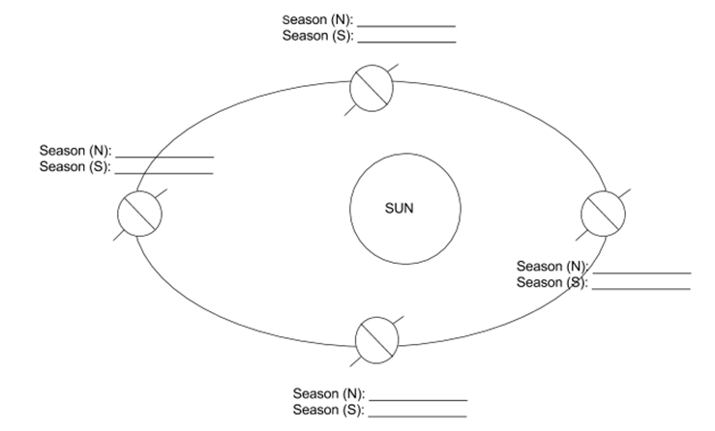
Identify the season for each hemisphere at the given locations.

