Practice: Stresses and Faults
Complete the table below based on the images provided.
Fault Image:  Label FOOT & HANGING walls if appropriate | Motion: Vertical or Horizontal | Caused by This Stress Type | Occurs at This Plate Boundary
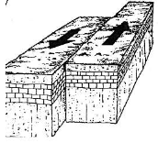
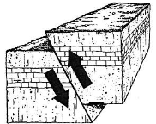
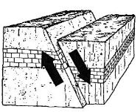
HONORS ONLY
HONORS ONLY

