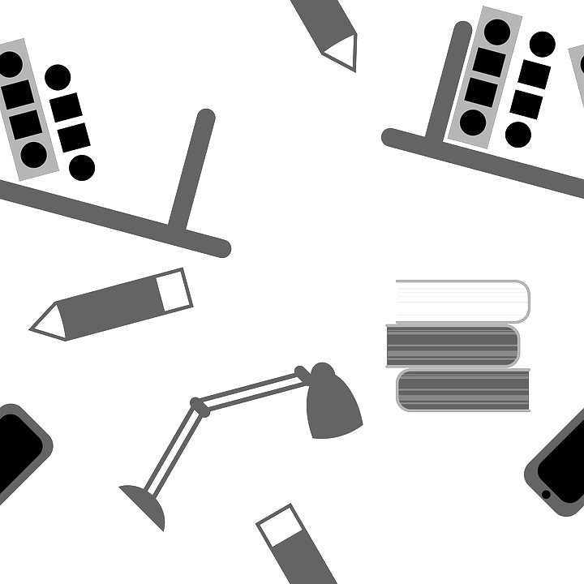
Study Tips and Techniques

Earth and Environmental Science 9

Study Tips
- Set an “Earth Science Time” for each day:
  - Put an alarm on your phone, put a sticky note on the TV, or in some other way make a schedule for yourself.
  - During this time, you should do homework, complete part of your Unit Sheet, study the day’s notes, and make notes of questions you have.
- Study daily:
  - Review your class notes, practice work, and activities each night. Use highlighters to mark key words and concepts (not whole blocks of information).
  - Try to do your homework without looking everything up at first, then go back and check your work using your notes. Mark which questions you did not know without using your notes.
- Share your knowledge:
  - Tell your parents what you learned today! Explain to them the key concepts, using your notes to help you if you get stuck.
- Use your resources:
  - Visit the class website. Look for tutorials, extra video clips, or just revisit the class notes/videos.
  - Use the digital textbook. Search for the current topic and read/watch how the same information is presented in a different way than in class.
  - Visit your favorite search engine! Find your own video explaining the most confusing topic from class that day.
  - Use Remind for questions needing immediate attention (that cannot be answered using the above resources).
  - Come to SMART lunch! Come with your work materials and good focus. Ask the teacher or your peers when you need assistance.

YOUR Favorites (from this list and/or past success)

- ________________________________________________________________

- ________________________________________________________________

- ________________________________________________________________

Study Techniques
- Passive--ways to start studying and review familiar information:
  - READ notes from class.
  - WATCH a video clip.
  - LOOK at a diagram.
  - LISTEN to someone else explain the information.
  - RECOPY notes.
- Active--deepen your understanding, remember it, and be prepared for a test:
  - NOTES/PRACTICE SHEETS
    - Look at the topic, cover the detailed notes, and EXPLAIN aloud or on paper everything you know about that topic. Then, uncover the details and see what you know/still need to practice.
    - Cover and REDRAW diagrams. ADD a written explanation of the information contained within the diagram. Uncover and check it.
  - FLASHCARDS
    - Take your notes and REORGANIZE them into written flashcards. Try putting questions, images, or concepts/topics on one side and details on the other.
    - QUIZ yourself, or have a friend or family member quiz you, using the flashcards.
    - Try MATCHING similar or opposite concepts/topics, then EXPLAIN the similarities/differences based on the detailed information.
    - CREATE your own sort! Make a blank copy of diagrams and try to fill them in either from memory or with flashcards.
  - STUDY BUDDY
    - Give a friend, teammate, or family member your notebook, flashcards, notes, or practice sheets to QUIZ you.
    - TEACH each other. Each pick your hardest topic and teach it to the other. When you get stuck, the other person provides a clue, key word, or can explain it to you and have you try again.

YOUR Favorites (from this list and/or past successes)

- ________________________________________________________________

- ________________________________________________________________

- ________________________________________________________________

