Name: ___________________________________________ Date: ________________ Period: _____
Unit 5 Notes: Oceans- Surface Currents
- *Ocean Currents-

  - Deep Currents- dense water located deep beneath the ocean’s surface
  - * Surface Currents-

- Mapping the surface ocean currents is crucial to understand ___________________ and _____________________ objects move across the sea.
- Nike shoes, gloves and the ducks have been used to determine the _________________ of ocean currents.
- The computer model of the duck takes into account wind speed, __________________ and ________________ to simulate the ducks path.
- Three factors control surface currents
  - *Wind Belts-

  - Coriolis Effect- The flow of currents, winds and weather systems are altered by the __________ of the Earth.
    - Northern Hemisphere- water spins to the ________________ *(______________________)
    - Southern Hemisphere- water spins to the ________________ *(______________________)
    - Earth’s _____________________ deflects the wind currents
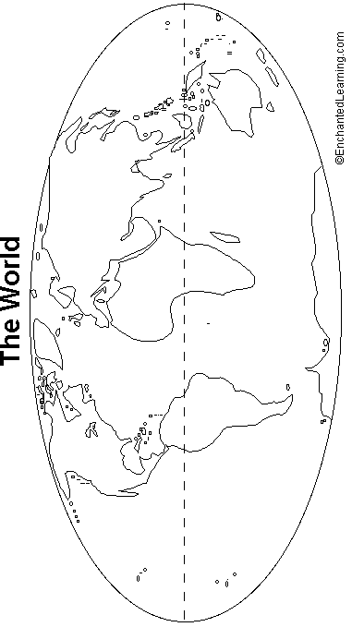
  - *Continents-

- Studying currents can be used to determine where an ______________________ will wash ashore or to back track to _____________________________________________.
- *Sketch the surface currents listed on the image below. Be sure to color code them base on temperature (red for warm, blue for cold). Gulf Stream, North Atlantic Drift, Canary, North Equatorial (2), South Equatorial (2), Brazil, South Atlantic, Benguela, South Pacific, Peru, California, and North Pacific.

