Thermohaline Circulation Video Notes
The Endless Voyage: Deep Connections

- What things do ocean currents move?

- What two factors influence currents?

- The driving mechanisms of currents are pressure difference created by differences in ________________________ and _________________.

- What happens to cold, salty water?

- How long does it take for water to complete a circulation circuit?

- What two locations are the primary areas of water sinking from the surface to the sea floor?

- How does the sea water get so cold and salty?

- Thermohaline circulation is also called _________________________.

- What controls the pattern of thermohaline circulation?

- How will the thermohaline circulation change, for perhaps a hundred years, if there is enough warming to melt sea ice and increase arctic precipitation?

- Ocean water that has distinct characteristics of temperature and salinity is called a ________________.

- These retain their temperature and salinity characteristics for about how long?

- What is the most important factor these move?

Thermohaline Circulation Follow Up

Analyze the diagram of the Great Ocean Conveyor provided. Then, complete the chart below describing where/how ocean water moves based on its temperature and salinity.

Temperature (Warm or Cold) | Salinty  (High or Low) | Location in Water Column (Shallow or Deep) | Direction of Travel in  Pacific Ocean  (N, S, E, or W) | Direction of Travel in Atlantic Ocean (N, S, E, or W) | Direction of Travel in  Indian Ocean  (N, S, E, or W)
Warm |  |  | S & W
Cold |  |  | North

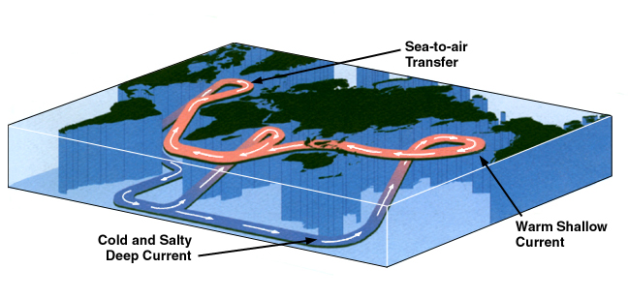

- Color the diagram of the Great Ocean Conveyor Belt below using the information from the chart above and the key provided.
Low Salinity: Red
High Salinity: Blue
Change in Salinity: Purple

