Unit 2 Formative Assessment (Days 1-4)

- Identify if each statement below corresponds to a normal, reverse, or strike-slip fault:

  - Footwall moves up _____
  - Hanging wall moves up _____
  - Footwall moves down _____
  - Hanging wall moves down _____
  - Land shifts horizontally _____
  - Caused by compression stress _____
  - Caused by shear stress _____
  - Caused by tension stress _____
  - Causes rivers, roads, and railroads to separate and shift _____

- Complete the table below regarding the layers of the Earth:
Layer | Relative Depth  (Outside, 2nddown, etc.) | Physical State  (Solid, Liquid, etc.) | Key Functions
 | Outside/exterior
 |  |  | Convection currents here drive plate motion
 |  |  | Produces Earth’s magnetic field
 |  |  | Heats the mantle to drive plate motion

- Use the word bank provided to label the image below:
divergent, convergent, mantle convection, mid-ocean ridge, low-density magma, high-density magma, subduction zone, continental volcano, magma breaking through crust
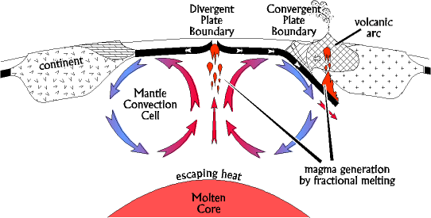

- Draw the mantle convection cell below each arrow that would produce the plate movements shown:

- Complete each of the statements below by choosing one option from each [ ].
  - Folded mountains are produced at [convergent/divergent] [oceanic-oceanic/continental-continental/ oceanic-continental] boundaries.
  - Rift valleys are produced at [convergent/divergent] [oceanic-oceanic/continental-continental/ oceanic-continental] boundaries.
  - Trenches are produced at all [convergent/divergent] where at least one piece of crust is [oceanic/continental].
  - Oceanic crust subducts because it is [thinner/thicker] and has [high/low] density compared to continental crust.
  - Old crust is recycled through subduction at [convergent/divergent] oceanic-continental and [oceanic-oceanic/continental-continental] boundaries.
  - [Divergent/convergent/transform] boundaries do not create or destroy crust.
  - [Divergent/convergent/transform] boundaries create crust.
  - [Divergent/convergent/transform] boundaries destroy crust.
  - Moving away from a mid-ocean ridge towards a subduction trench, the crust will get progressively [older/younger], and the magnetic pattern of the rocks within the crust will [always point north/be random/mirror the pattern on the opposite side of the ridge].
- Compare the lithosphere and asthenosphere.

  - Similarities

  - Differences

- Match the term to its description:

  - Mantle Convection

  - Ridge Push

  - Slab/Gravity Pull

  - Weight of the high-density subducting plate pulls it into the mantle.
  - Low-density magma rising from within the mantle breaks through crust and pushes aside the older pieces.
  - Magma is heated within the lower asthenosphere, becomes hot, decreasing the density, causing it to rise towards the crust. The magma cools while rising, becoming denser, and sinks back into the lower asthenosphere.

- Create a Venn Diagram on the back of this sheet to compare the Continental Drift Hypothesis to the Theory of Plate tectonics. Include the following:
  - 1912
  - Present day
  - Wegner
  - Admiral Hess
  - Seafloor spreading
  - Satellite tracking of plates
  - Coastlines that match like puzzle pieces
  - Fossils, land features, and rock types that match across continents
  - Rejected for no proposed explanation of how movement happens
  - Lacks mechanism to explain how the motion occurs
  - Continents move across Earth’s surface
  - Earth’s lithosphere is broken into multiple pieces that float on top of the asthenosphere and move around due to mantle convection
  - Magma lower in the asthenosphere heats up, rises towards the crust, cools, and sinks back down

