Unit 6 Media Evaluation Name ____________________________ Date _________ Pd ___

Kostigen, Thomas M. "California's Recent Heat, Humidity Nothing Compared to Iran." USA Today. Gannett, 05 Sept. 2015. Web. 15 Mar. 2016.

California's recent heat, humidity nothing compared to Iran
Thomas M. Kostigen, Special for USA TODAY6:02 a.m. EDT September 5, 2015
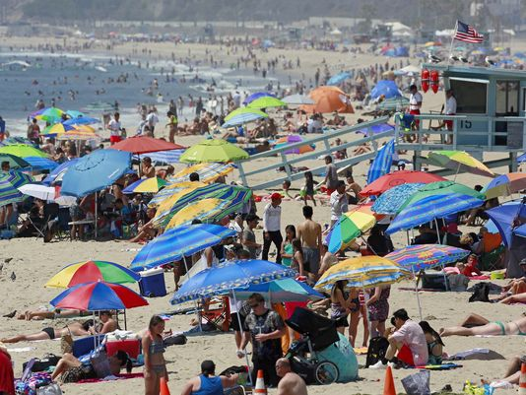
(Photo: Nick Ut, AP)
Over the past few weeks, California has been plagued by a weather phenomenon that many on the East Coast would shrug off — humidity.
California is a Mediterranean climate and typically experiences dry summers and wet winters. But not this year.
The heat index, a measurement of how hot it feels when relative humidity is added to the actual temperature outside, has reached dangerously high levels. The National Weather Service has issued special alerts, warning that heat index values may approach critical levels in some areas.
The East Coast is far more accustomed to humidity because the air is moistened by the Bermuda High, a high pressure zone that moves warm ocean air from the western North Atlantic (near Bermuda).
The normally cooler Pacific Ocean that keeps much of the California coast dry is being heated this year by an El Niño effect and, when combined with other factors such as wind direction, is dampening conditions. In winter, that clash of warm and wet air may produce record rains. For the time being, there are steamier results — and they can take a toll on health.
The heat index was developed as a counterpart to the wind chill factor to exemplify health consequences. Humidity, when added to either hot or cold temperatures, can dramatically impact what it “feels” like. For example, if the temperature is 96 degrees and the relative humidity is 65%, it actually feels like a scorching 121 degrees. Direct sunlight can make it seem even hotter.
The National Weather Service provides a Heat Index Chart showing when to take caution. A mere 80 degrees with relative humidity of 40% begins the likelihood of heat disorders with prolonged exposure or strenuous activity. Extreme danger kicks in at 108 degrees. The NWS initiates alerts when the heat index is expected to exceed 105 to 110 degrees for at least two consecutive days. Because the index was devised for shady, light wind conditions, exposure to full sunshine can increase heat index values by up to 15 degrees. To accommodate areas with high heat but low relative humidity, the agency developed yet another chart to model warnings.
The global warming trend is putting heat index values to greater use. Higher temperatures in the atmosphere allow more water vapor to remain in the air. This manifests as moisture until shaken loose as precipitation by weather events, which is why storms are becoming more intense across the globe.
A wicked example of humidity’s charge on temperatures took place in Iran last week. In Bandar Mahshahr, the second highest heat index temperature ever —165 degrees — was recorded. That reading has only been eclipsed by a “feels like” 178 degrees in Saudi Arabia in 2003.
While we Californians may complain about the recent spate of heat and humidity, the bar for griping has been set much higher.
Even at cautionary levels of heat index values, it’s wise to seek cool shelter or shade. Also remember that fans won’t cool things down and prevent heat-related illness when temperatures get into the high 90s. Additional moisture on skin, too, can fool the body into believing it’s cooling itself when in fact it’s heating up inside. So drink plenty of liquids.
In other words, mind the water in the air as well as on your skin.

Answer the following in complete sentences. In addition, you must highlight/underline and number the text to show where you found your information. When answering, use the space on the back of this sheet or attach another sheet of paper. Do NOT answer next to/below the questions.
- Describe California’s Mediterranean climate.
- What does the heat index measure?
- How does the Bermuda High moisten the air on the East Coast?
- Why was the normally cooler Pacific Ocean warmer in 2015?
- Give an example of how the heat index accounts for the humidity in the air.
- At what conditions does the likelihood of heat disorders begin for someone who is playing a sport or otherwise extremely active outdoors?
- What is the effect of exposure to direct sunlight on the heat index value?
- As atmospheric temperature increases, what happens to the amount humidity (water vapor in the air)?
- When, where, and what were the top two heat indexes ever recorded?
- What is the health risk of evaporative cooling (when the skin cools as moisture evaporates from it)?

