Unit 5 Notes/Activity: Upwelling

Notes:
What upwelling is
- ______________________________________________________________________

______________________________________________________________________
- Animation: Describe upwelling in your own words

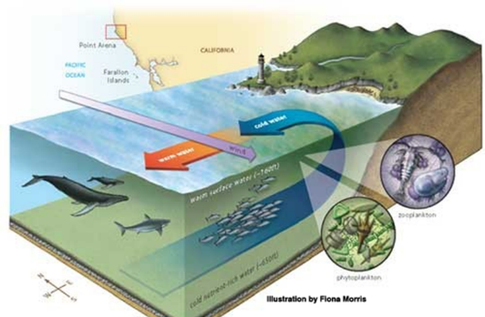
What upwelling does
- ____________________________________________

____________________________________________

- ____________________________________________

____________________________________________

______________________________________________________________________

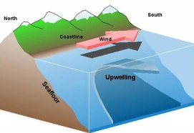
How upwelling happens
- ______________________________________________

______________________________________________

- ______________________________________________

______________________________________________

______________________________________________________________________

- ______________________________________________________________________

______________________________________________________________________

Activity:
Procedure
  - Fill the container with room-temperature water to about 1/2 inch from the top.
  - Let the pan sit undisturbed until the water is quiet, about 5 minutes.
  - Slowly pipette a few drops of cold, colored water at the bottom (near one end) of container.
  - Rest the straw on the end (opposite the colored water) of the container. Gently blow across (not into) the water, creating offshore waves.

Analysis/Conclusions
- Which water was “nutrient-rich”? Where is it originally located?

- What happened to the surface waters when the “wind” blew?

- What happened to the deeper water when the “wind” blew?

- Describe upwelling. Illustrate your explanation.

