Screening | Removes trash, rocks, animals, and other large debris
Because these objects would clog the filters and machinery used in the rest of the treatment process (does not affect water quality) AND their decay would deplete oxygen in the natural environment | 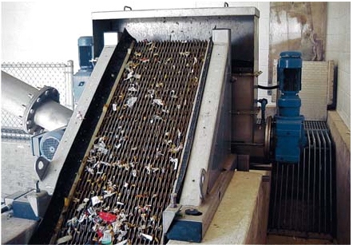
Pumping | Moves water into aeration tanks
Because water can’t flow uphill (does not affect water quality) | 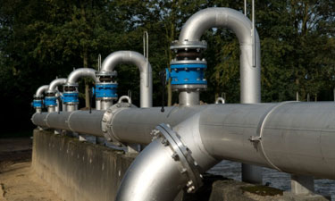
Aeration | Bubbles air into/agitates the water
Because oxygen is needed for the decay of small pieces of organic matter, and it separates the grit (sediment settles to the bottom to aid its removal) | 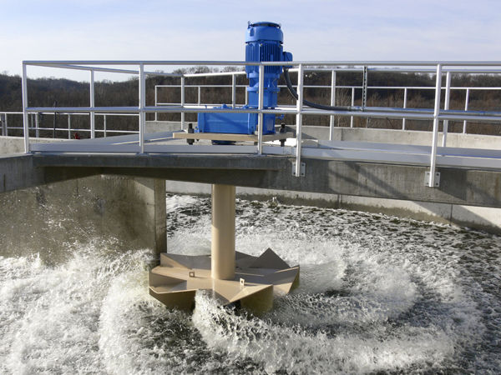
Sludge Removal | Removal of the organic matter that settled to the bottom of the tank
Organic matter can cause increased nitrates and phosphates, leading to algal blooms and then oxygen depletion | 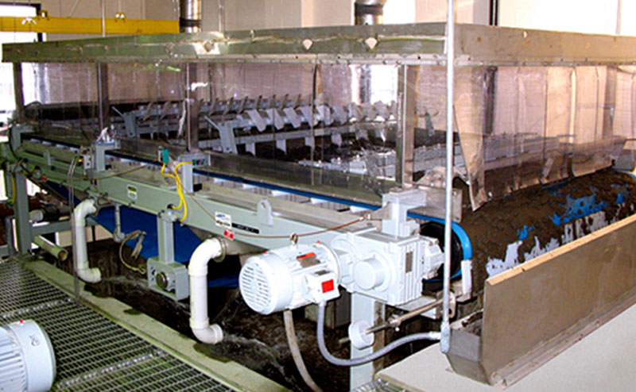
Scum Removal | Removal of floating materials (such as grease, oil, and soaps)
Because these items increase the turbidity of the water which would block sunlight from reaching plants AND would cause the temperature to increase, decreasing the dissolved oxygen | 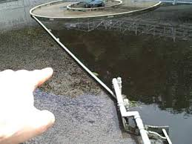
Disinfection | Addition of chlorine followed by neutralization of any excess
Because it kills the bacteria that could cause disease among wild animal populations | 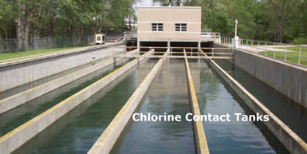
Residuals | Sludge is stored in tanks or buildings
Because bacteria need time to decay the organic material and remove disease-causing organisms | 